MINI PROJECT ON GIT

Github Link: <https://github.com/NiteeshManne?tab=repositories>

1.Login to the aws console.

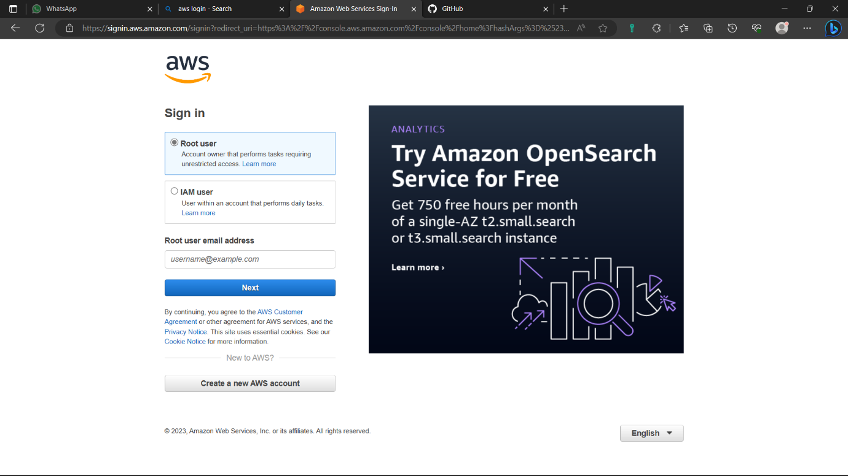

2.On the top left in the search button type ec2. Then select the ec2 option from below.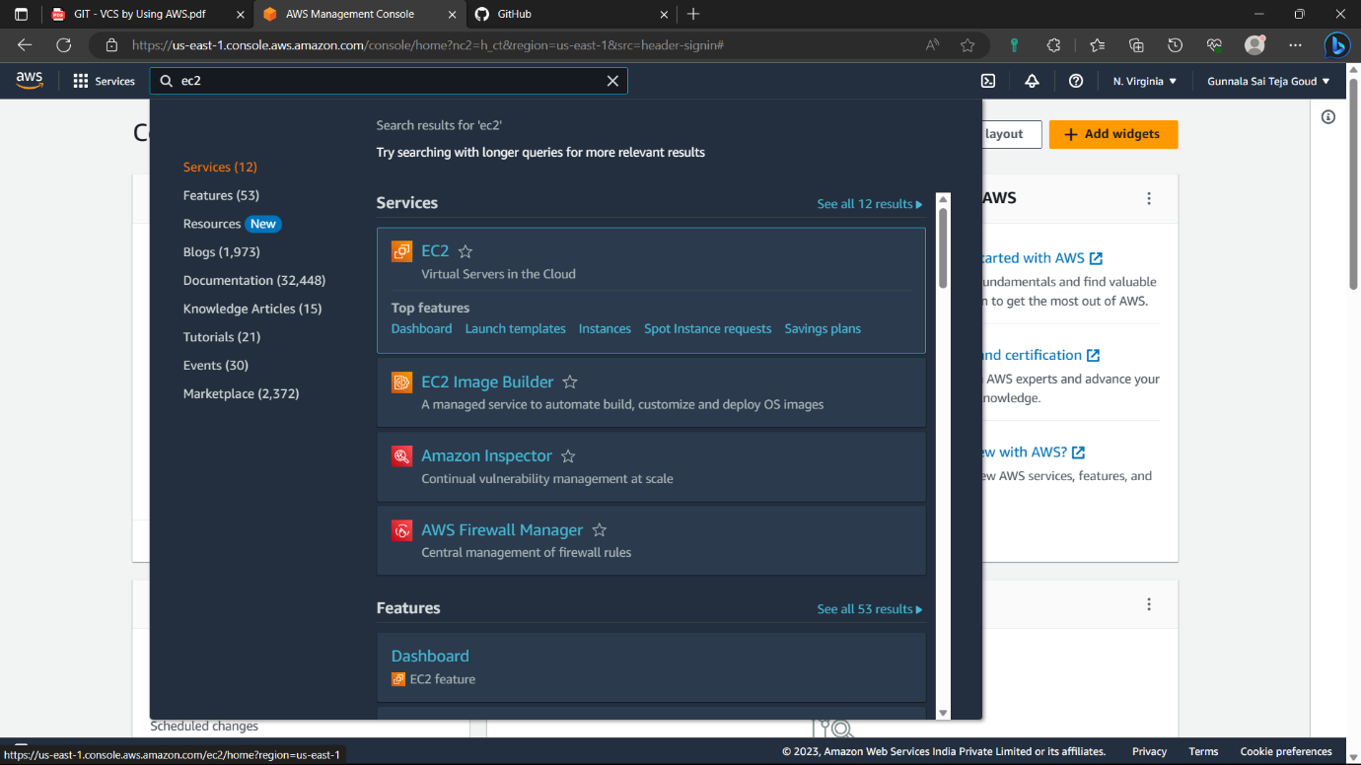

3.Select the launch instance option at the top right corner to create an ec2 instance.

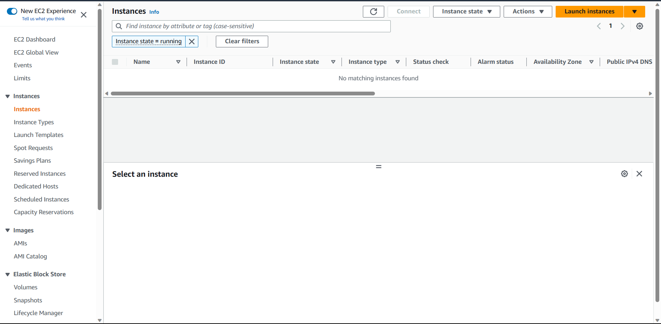

4.Give name to server, and select AMI-Linux, version-latest(Free Tier), description, Architecture.

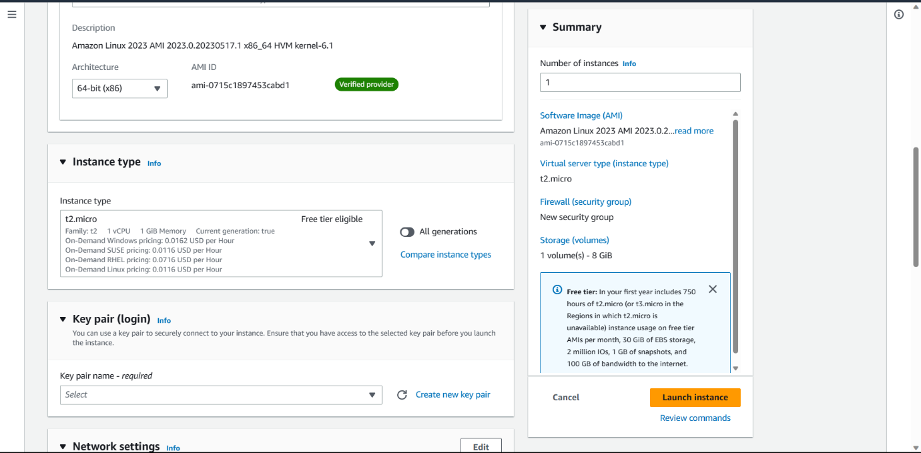

5.Select the instance type-t2.micro(Free Tier), Select the key pair i.e., downloaded in your local host at the time of creation.



6.Let the network settings default if you didn’t create vpc (or) if you create a vpc you can assign it by clicking on edit option. Enable the http option.

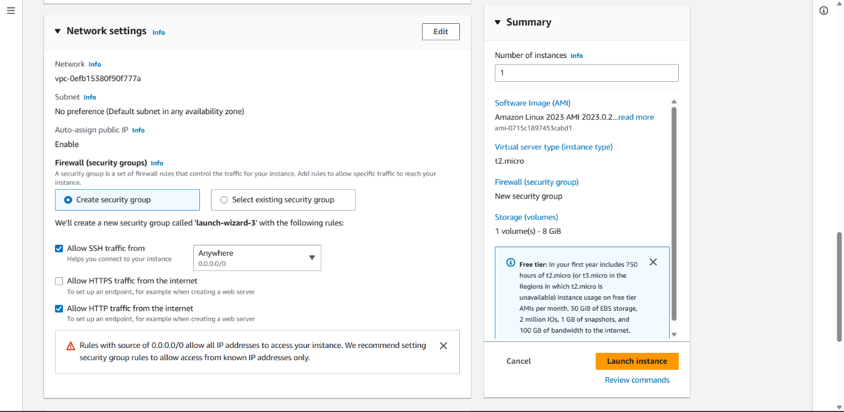

7.At configure storage, you can extend the storage if you want else you can let it be default. And review everything at summary. Click on launch instance.

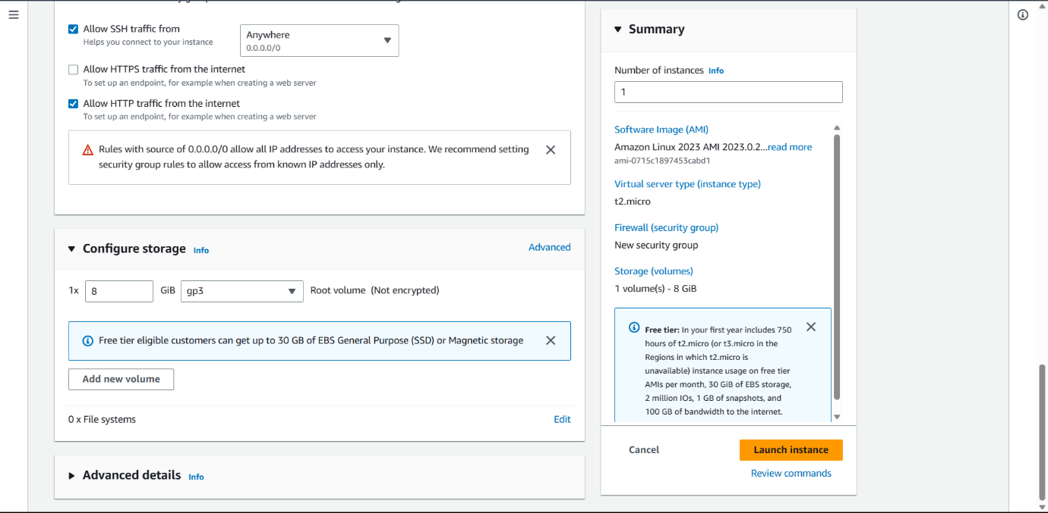

8.Now the instance is created. Now go to instance option at the top left corner above success.

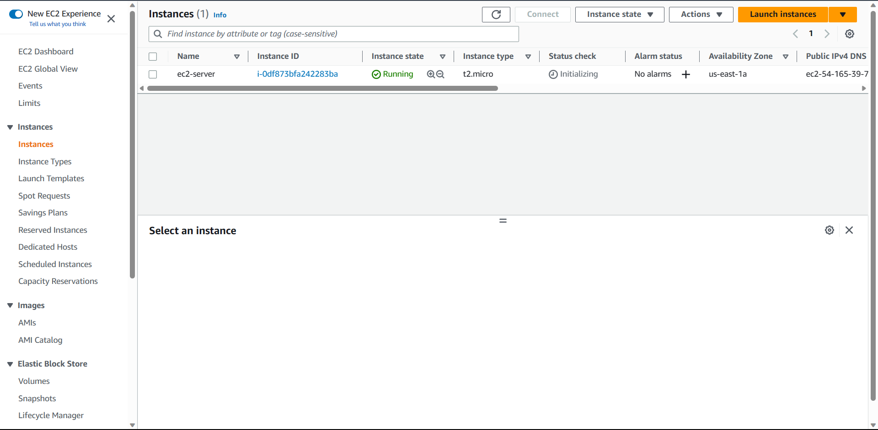

9.Now wait till the instance state-Running, status check-2/2 passed is shown. Then select the created instance and click on connect option at the top.

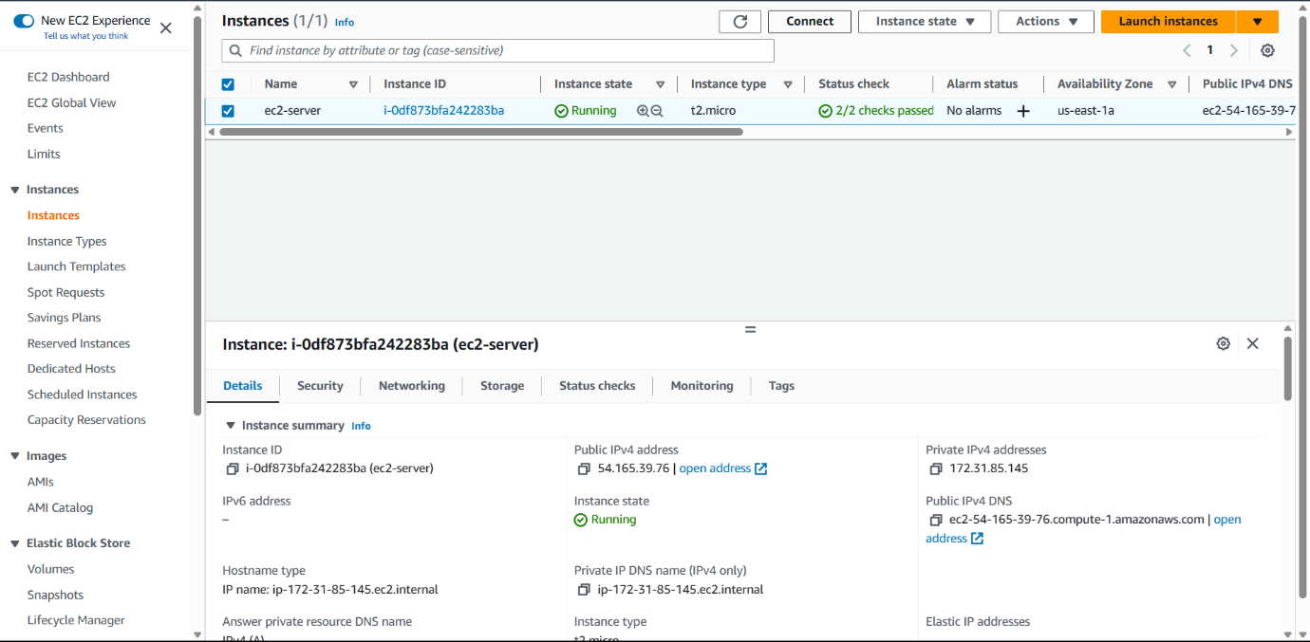

10.Click on the ssh client and copy the the command below the example.

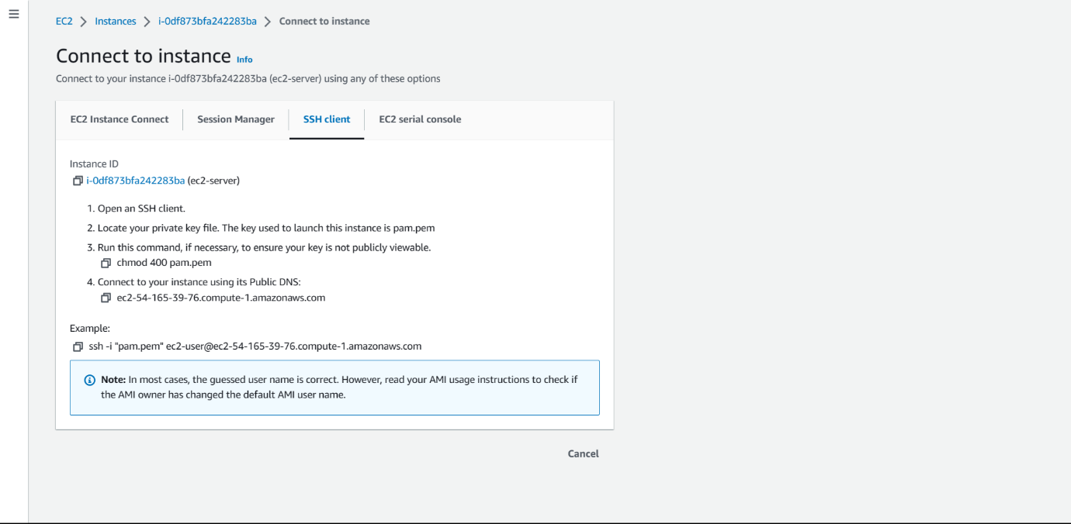

11.Now open the git bash.

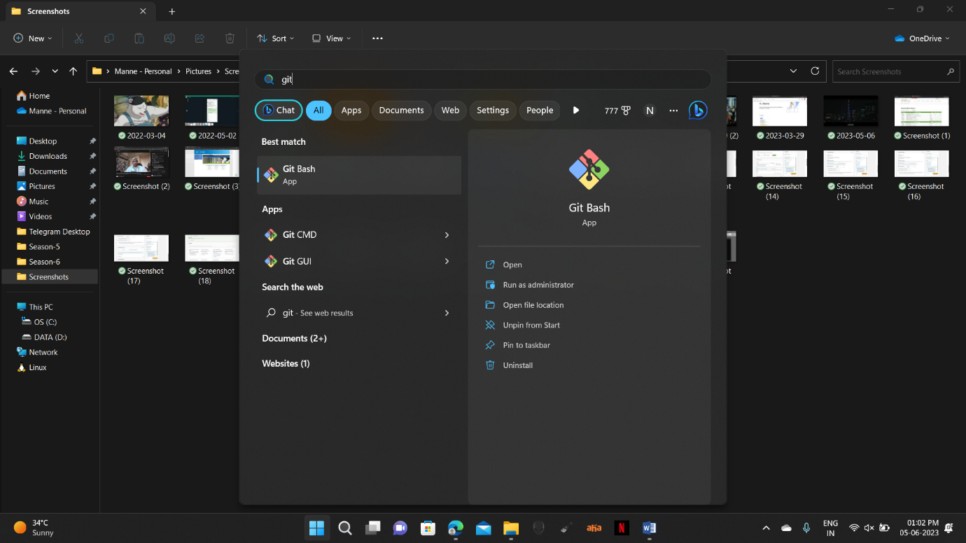

12.Now type the command “cd downloads” because the key pair is saved in in downloads. So, we navigate to downloads.

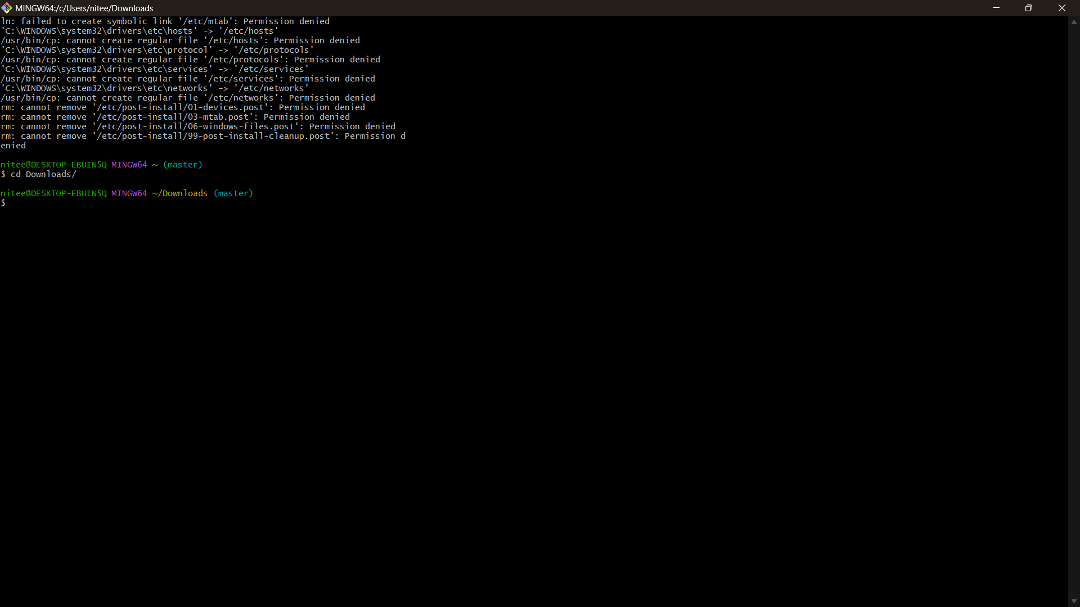

13.Now the command that is copied at step-10. Paste it in the command prompt.-(“ ssh -i "pam.pem" ec2-user@ec2-54-165-39-76.compute-1.amazonaws.com”).Now we are connected to the ec2 instance.

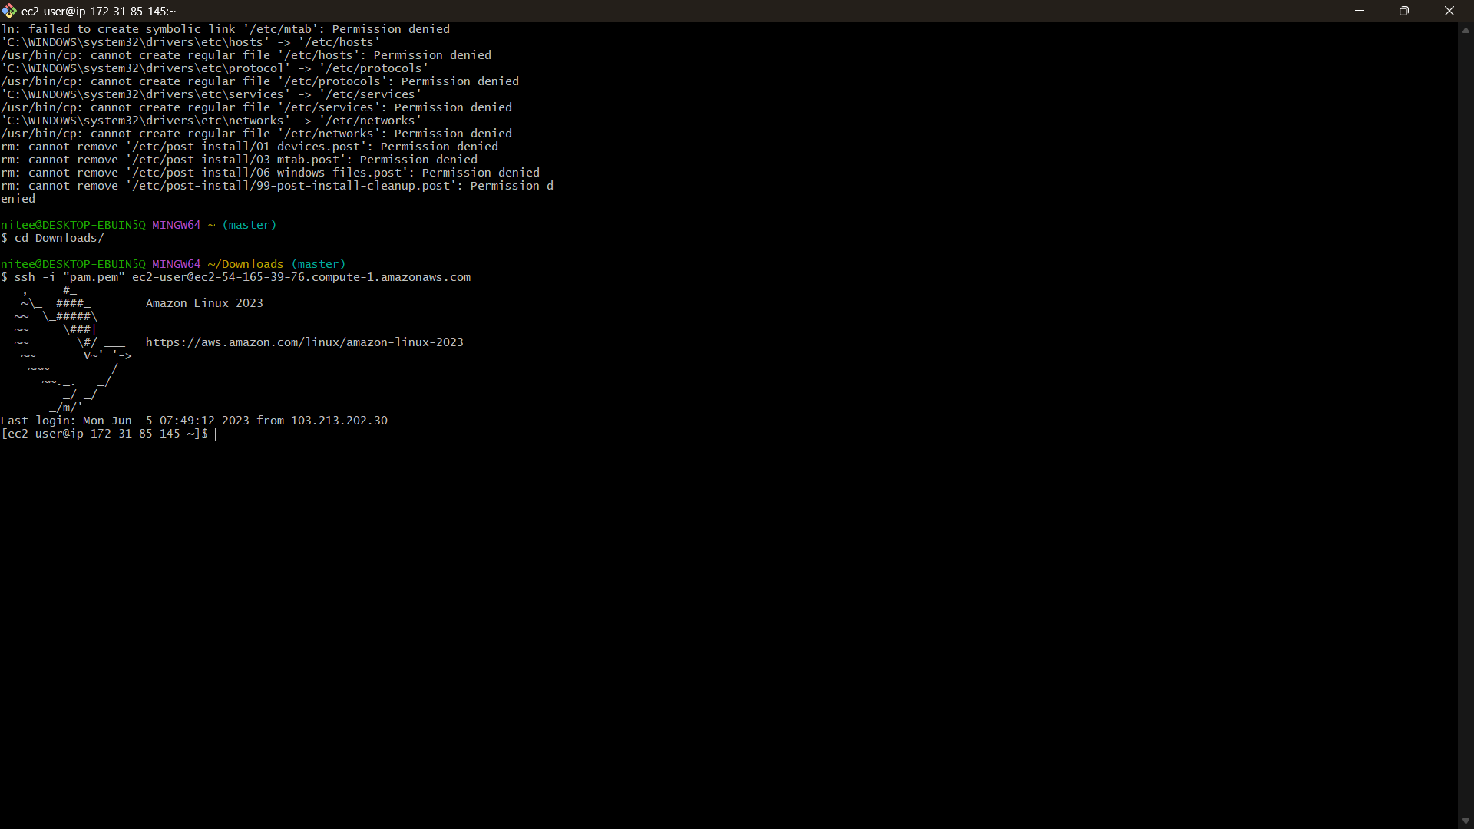

14.Now install the git in the instance using the command- “sudo yum install -y git”.

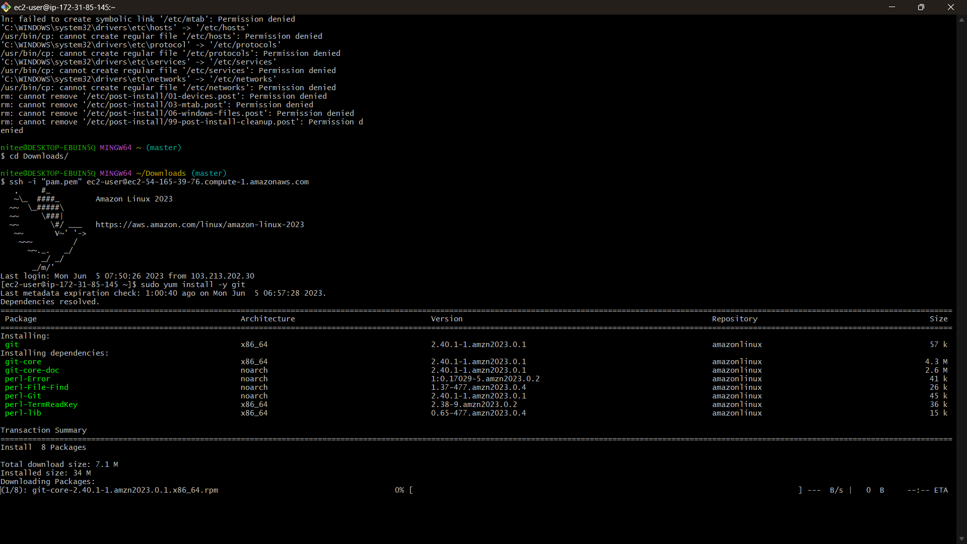

15.Create a folder and initialize it by using the command-“git init <foldername>” –“git init ben”.(Both creation and initialization of the folder can be done using this command).

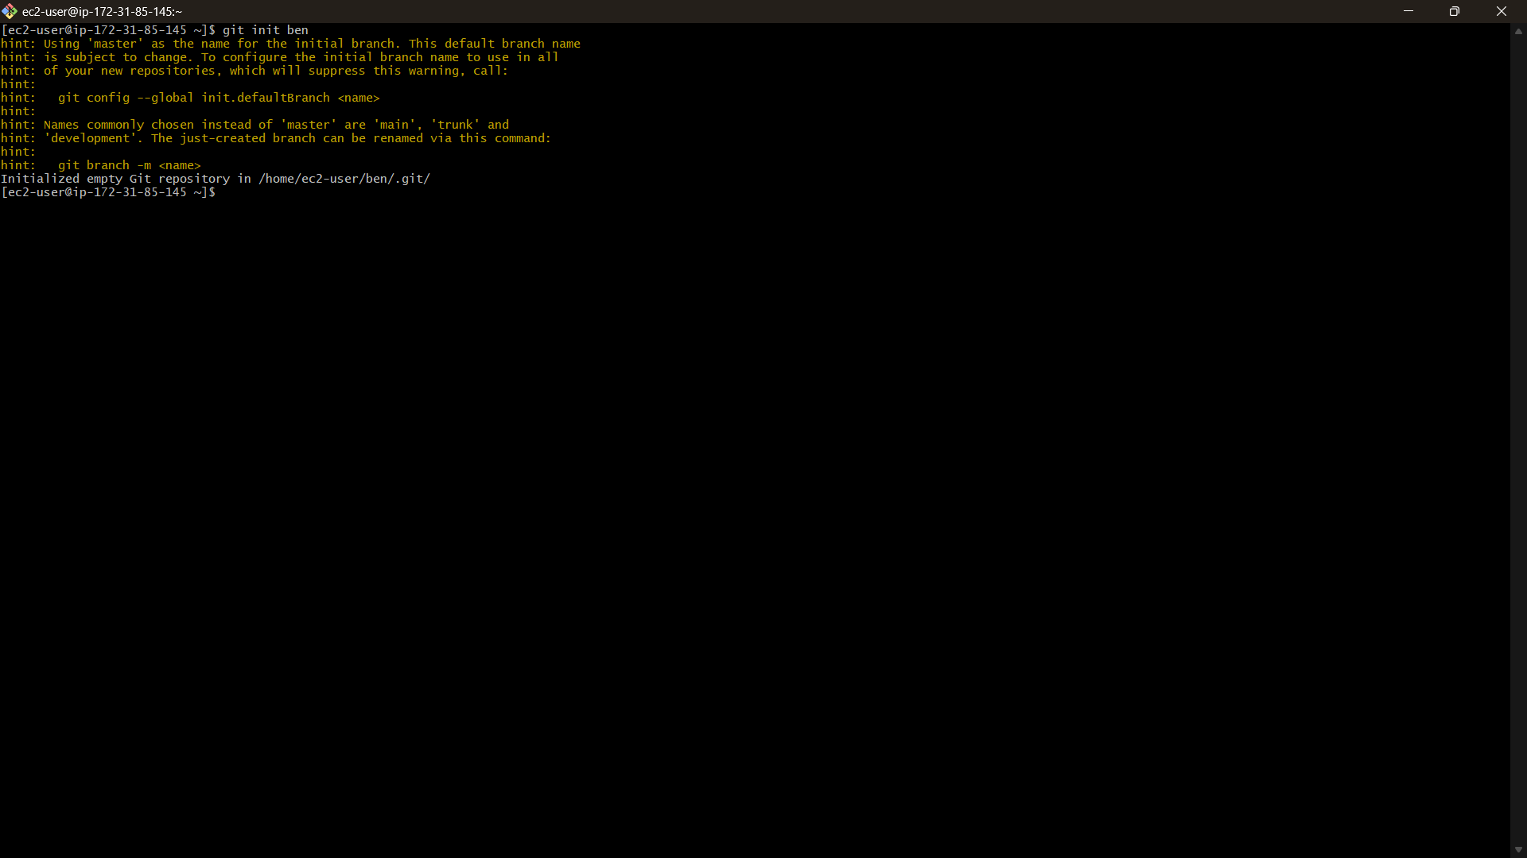

16.Go inside the folder using the command –“cd <foldername> - “cd ben”.

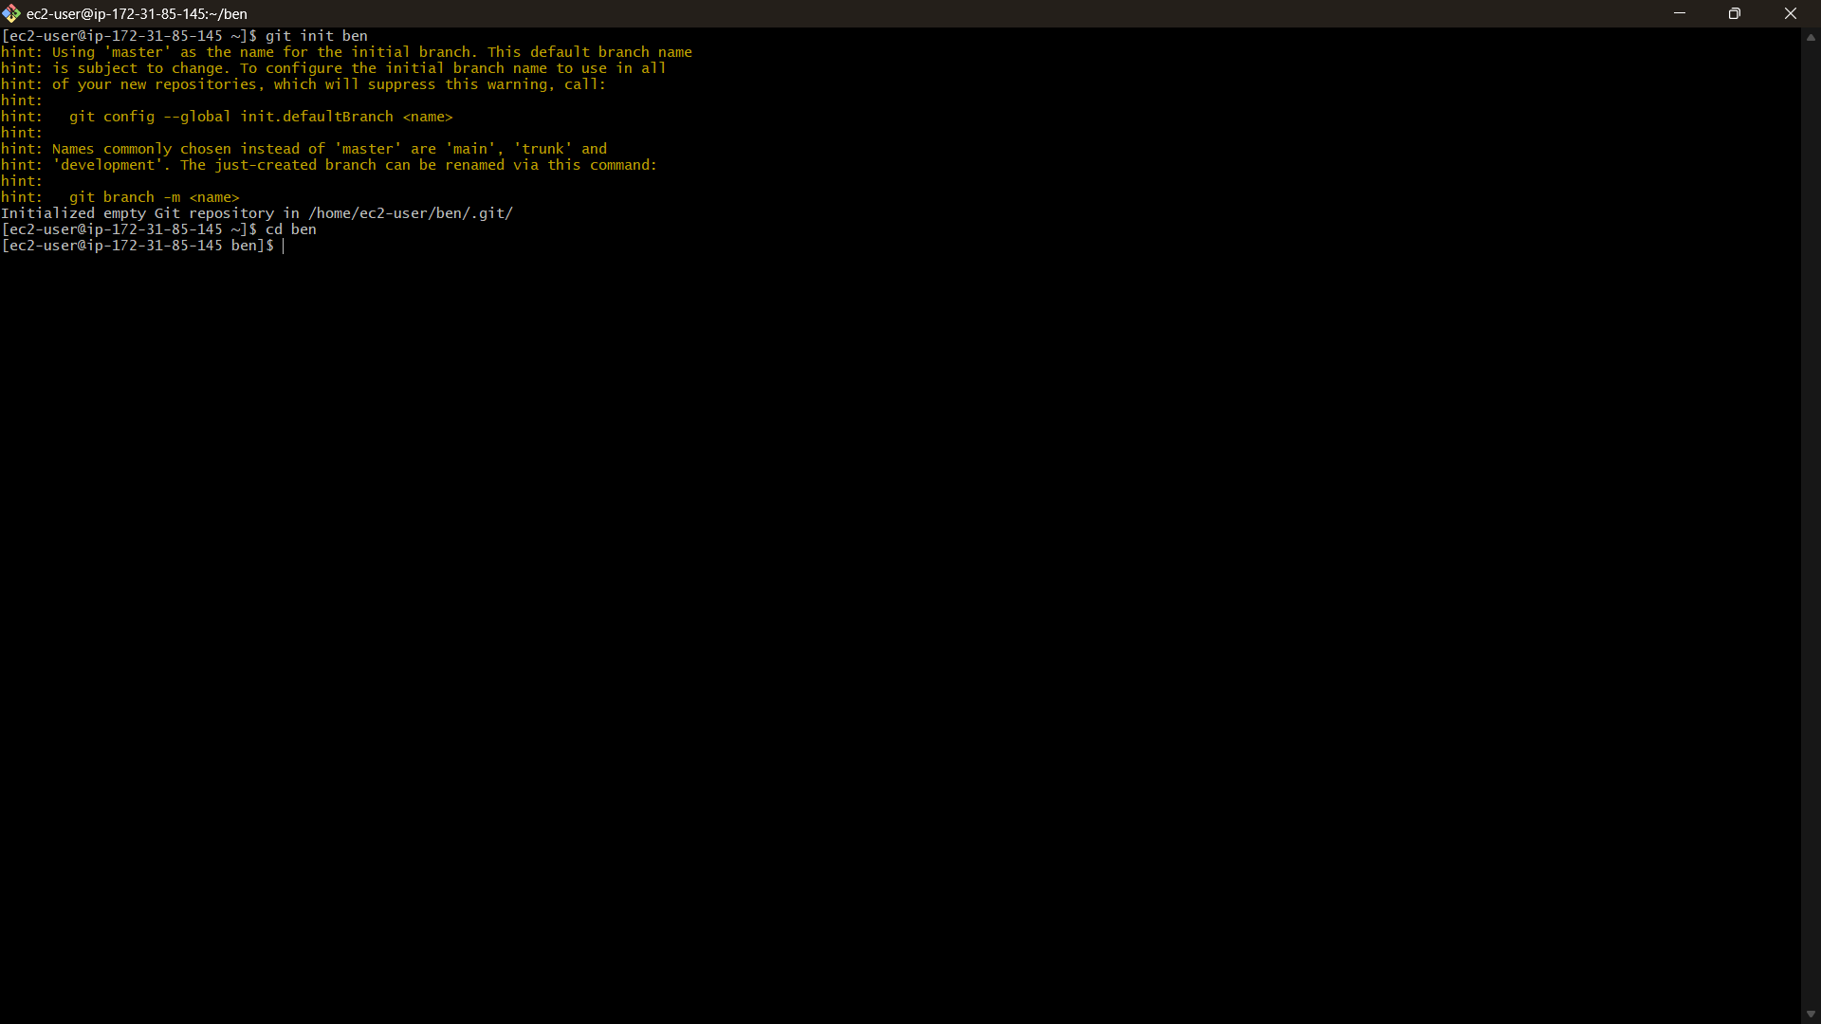

17.Now create a file inside the folder using the command- “touch <filename>” - “touch gar.txt”.and check it by using the “ls” command.

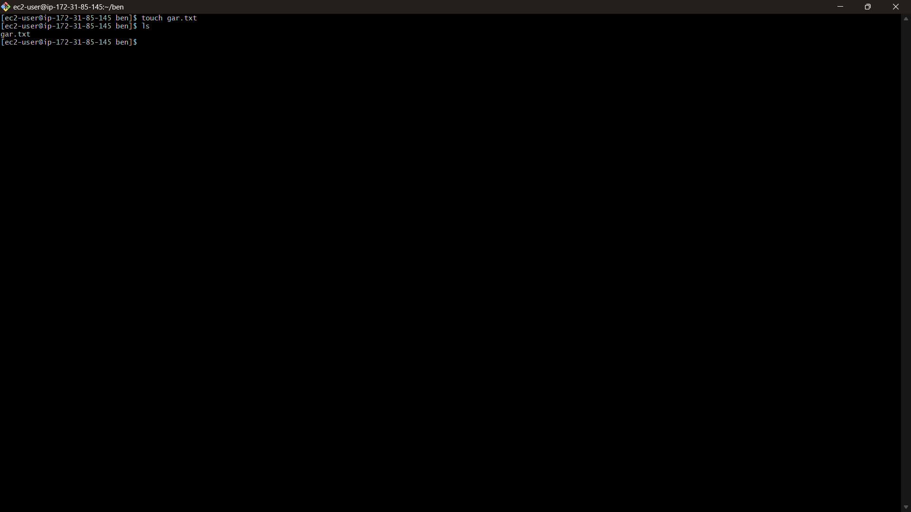

18.check the git status using the command- “git status” (it will help to check whether the file is being tracked by git or not).we can see it is not tracked.

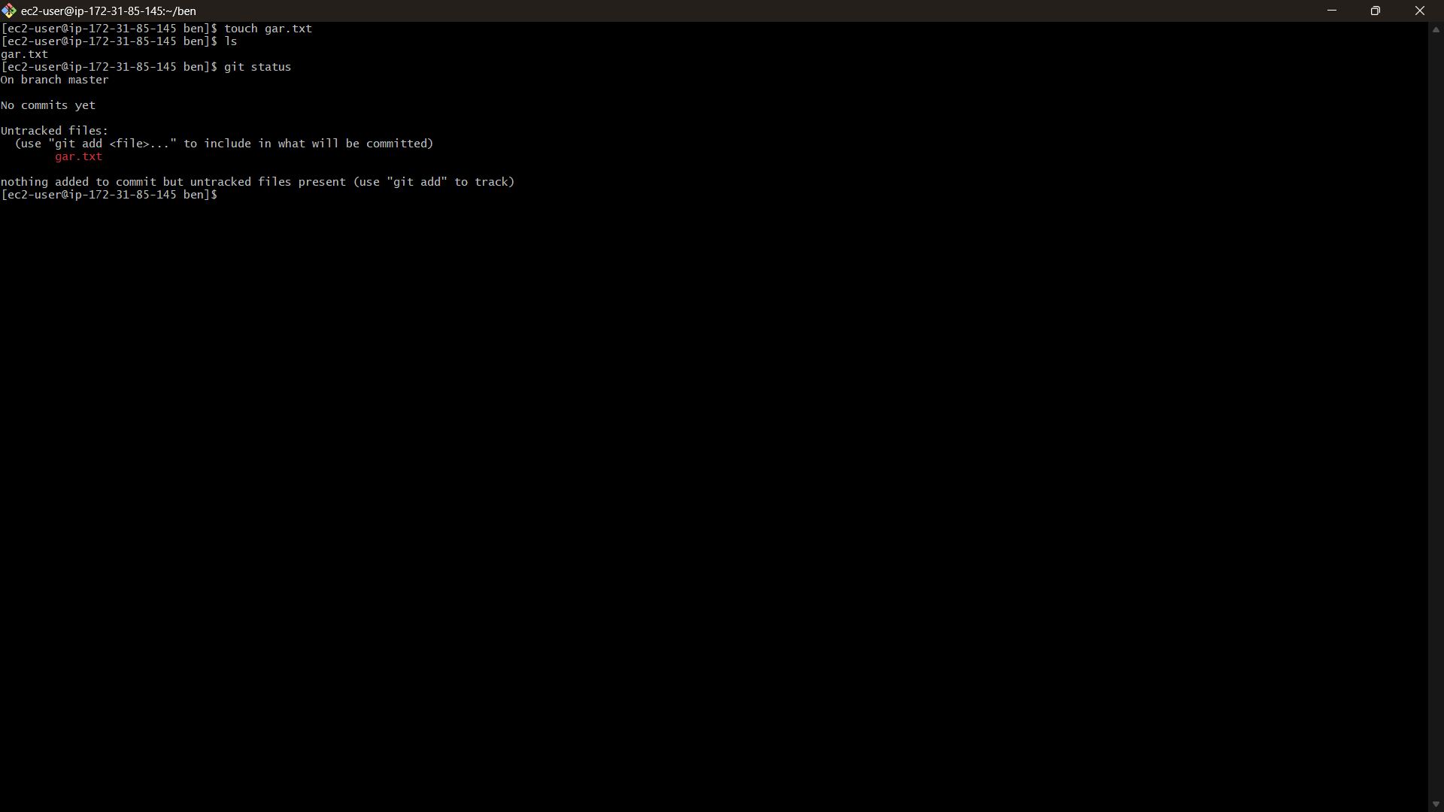

19.Now type the command –“git add filename” – “git add gar.txt”. now check the status. We can see it in green color.

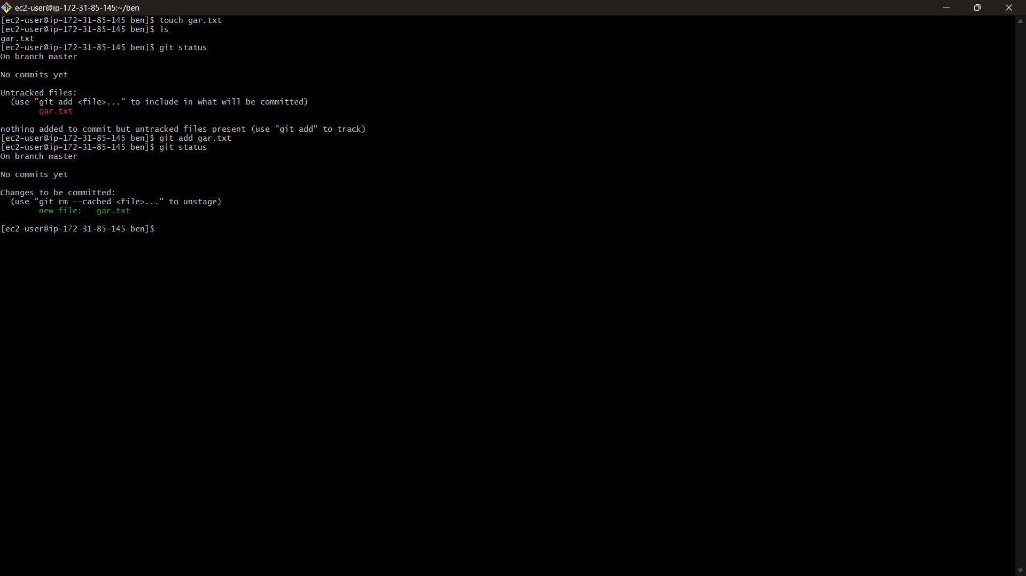

20. Now commit the file using the comman- “git commit -m “message” - “git commit -m “added test files””

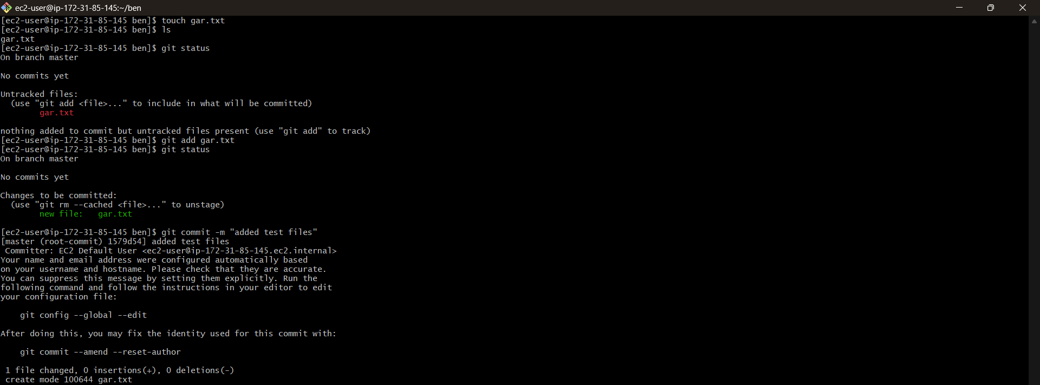

21.Now check the status. It shows the tree is clean. Beacause the commit command will move the file from staging area to the local repository.

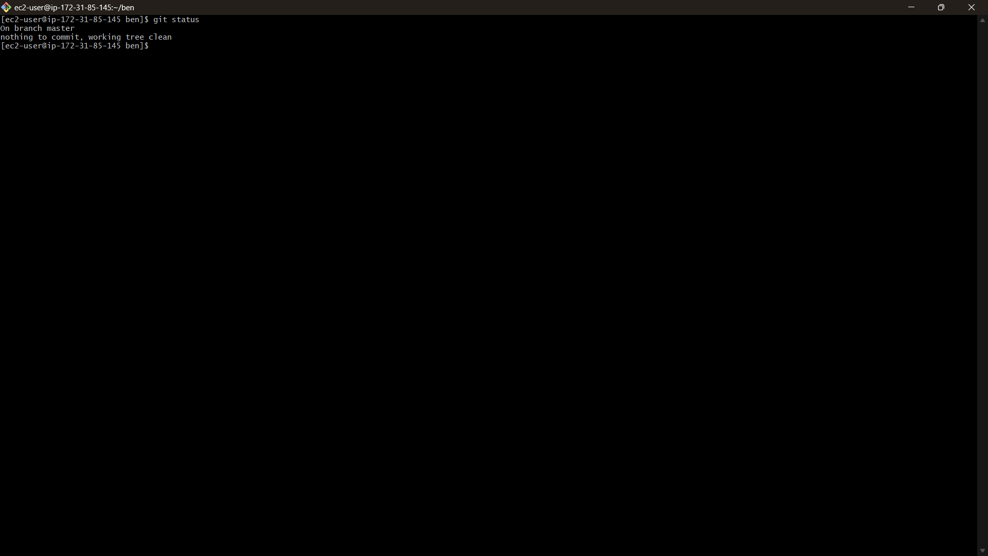

22.Now login to your github account.

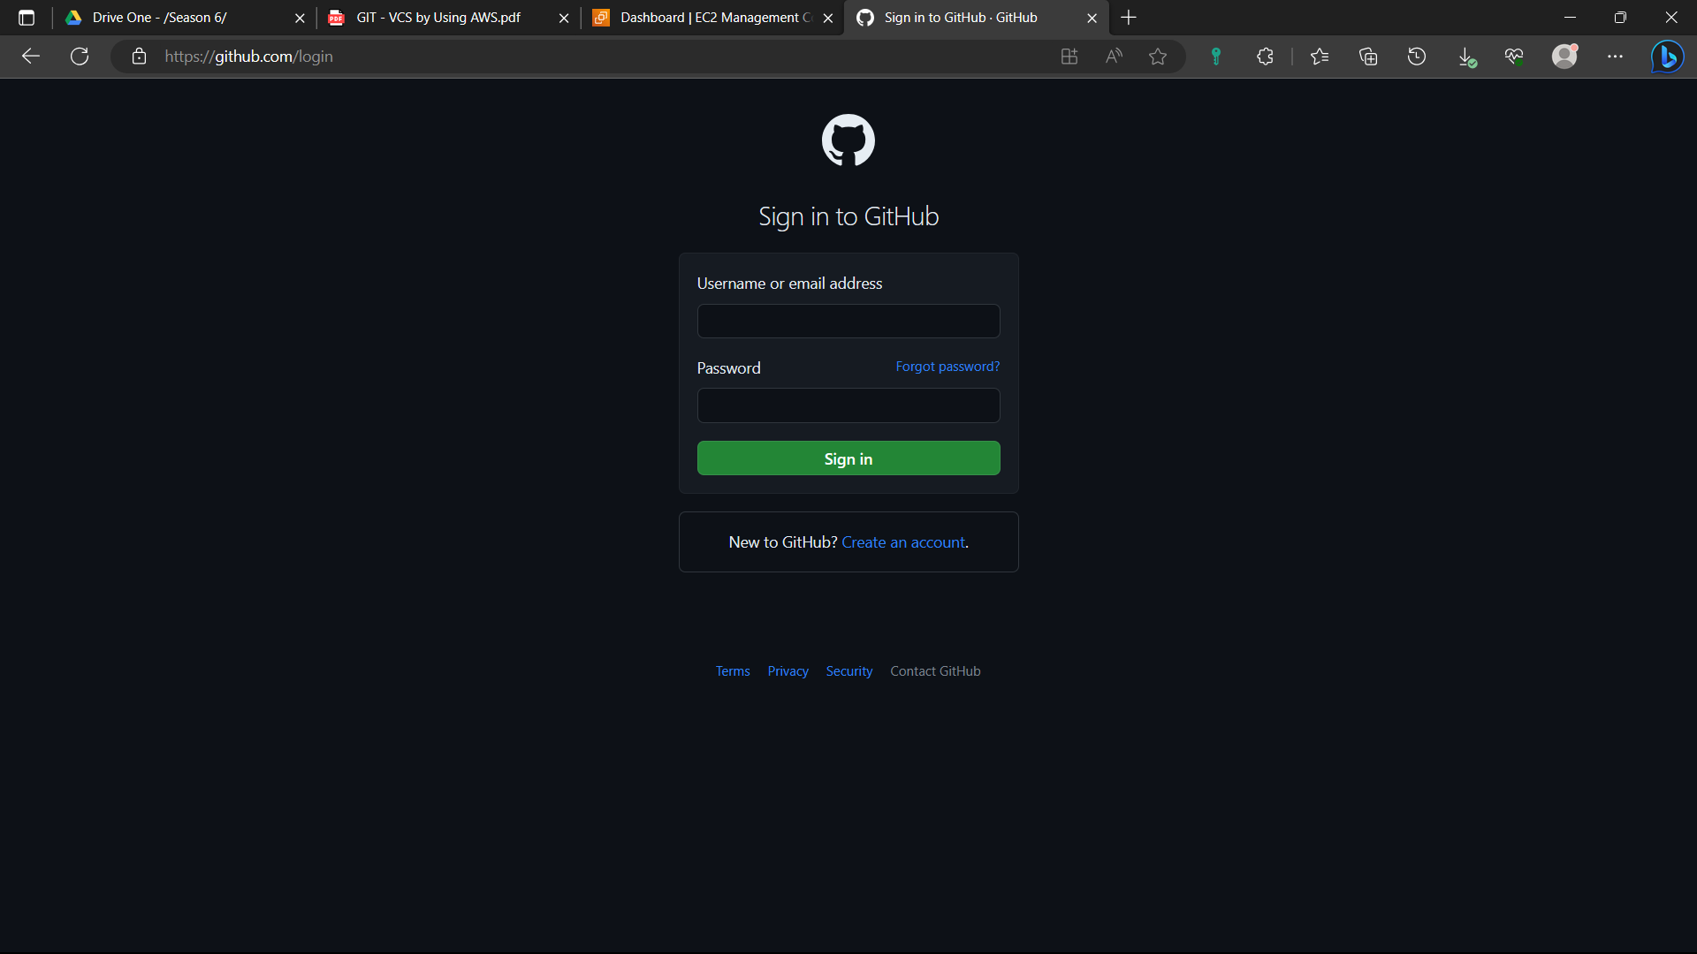

23.Create a new repository by clicking on create repository option at the top left corner.

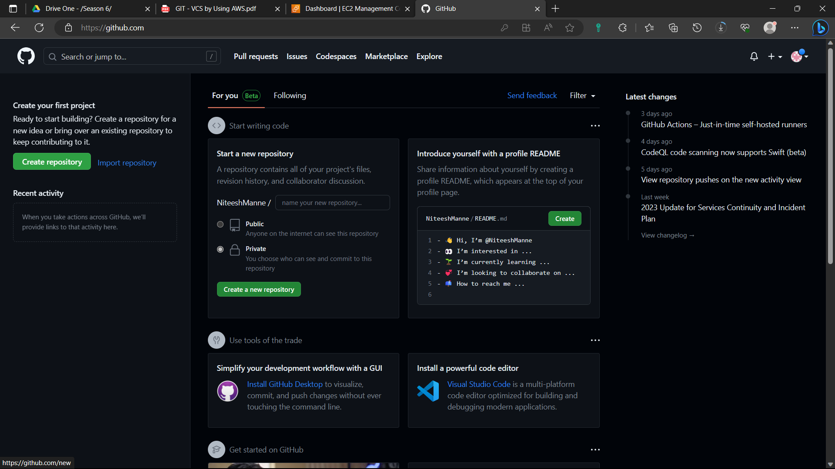

24.Give a name of your choice, select public and initialize README.md file. Then click on create repository.

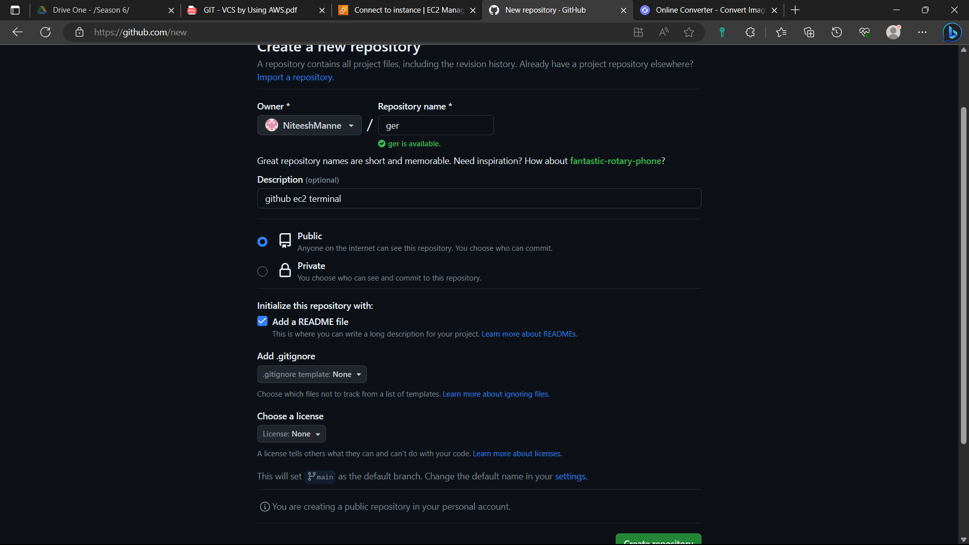

25.Now the repository is created.

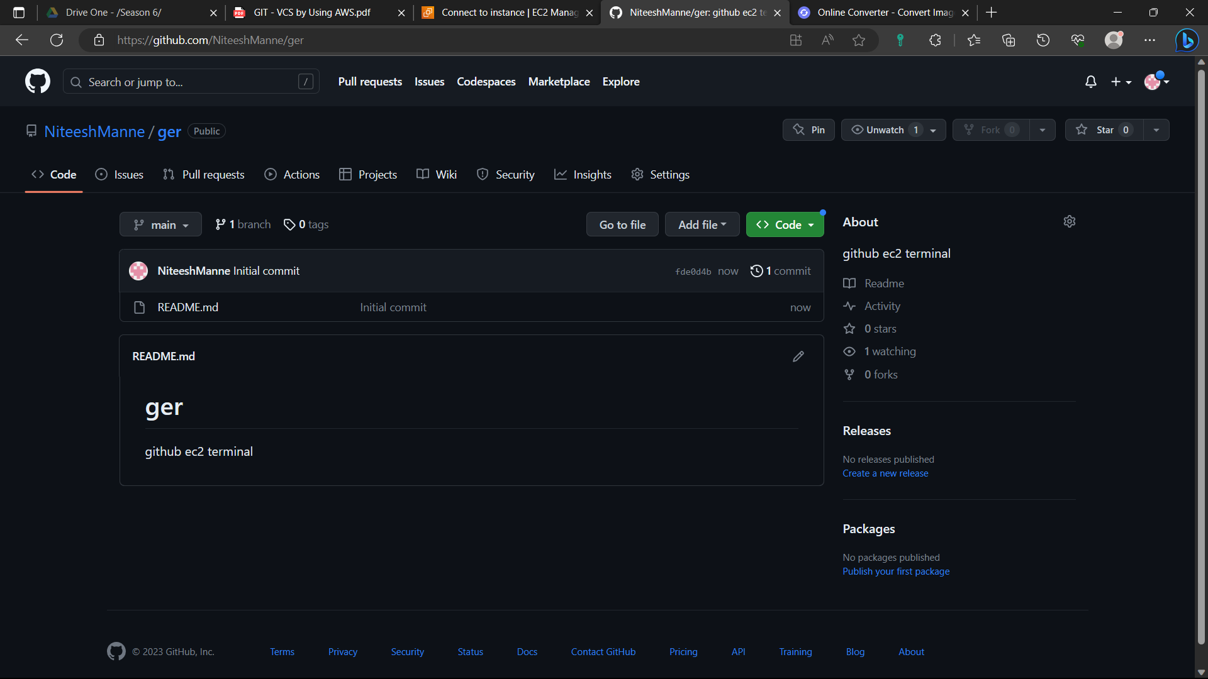

26.Now we will connect github to our local machine. For that we have to generate personal access token. For that at top right corner of user click on settings.

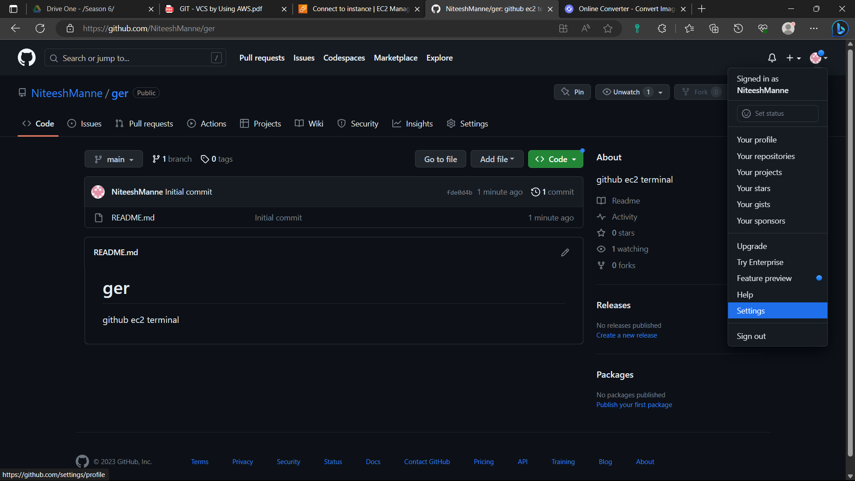

27.Now go to developer settings which located at the bottom of options.

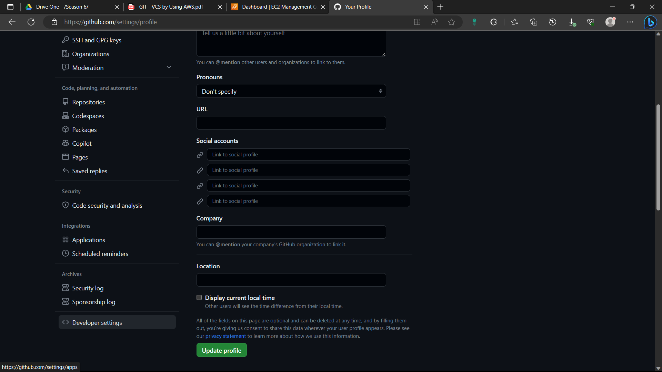

28.Now click on personal access token, and click Generate new token.

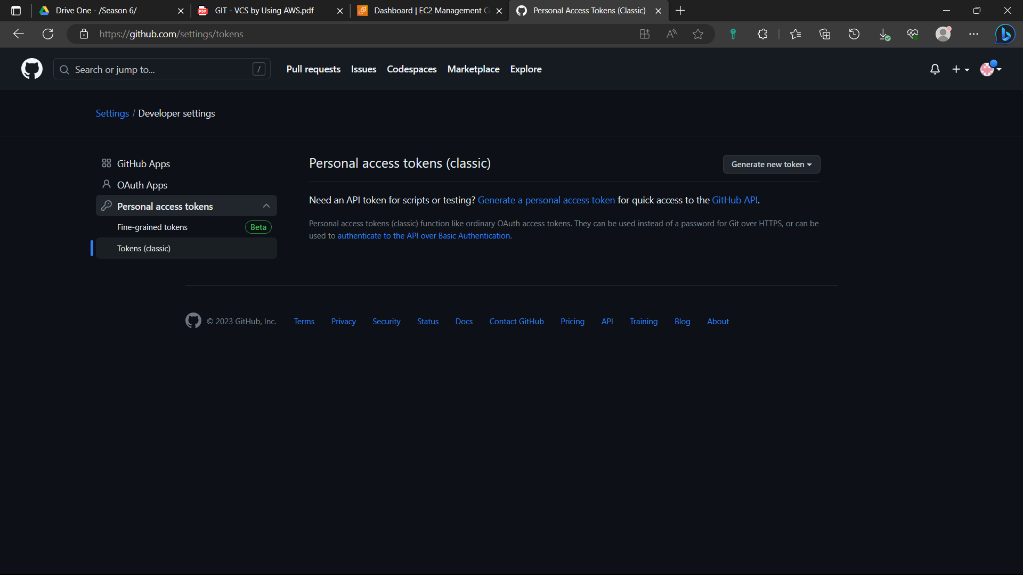

29.Now give the description about the token use, expiration date, scope-enable repo.

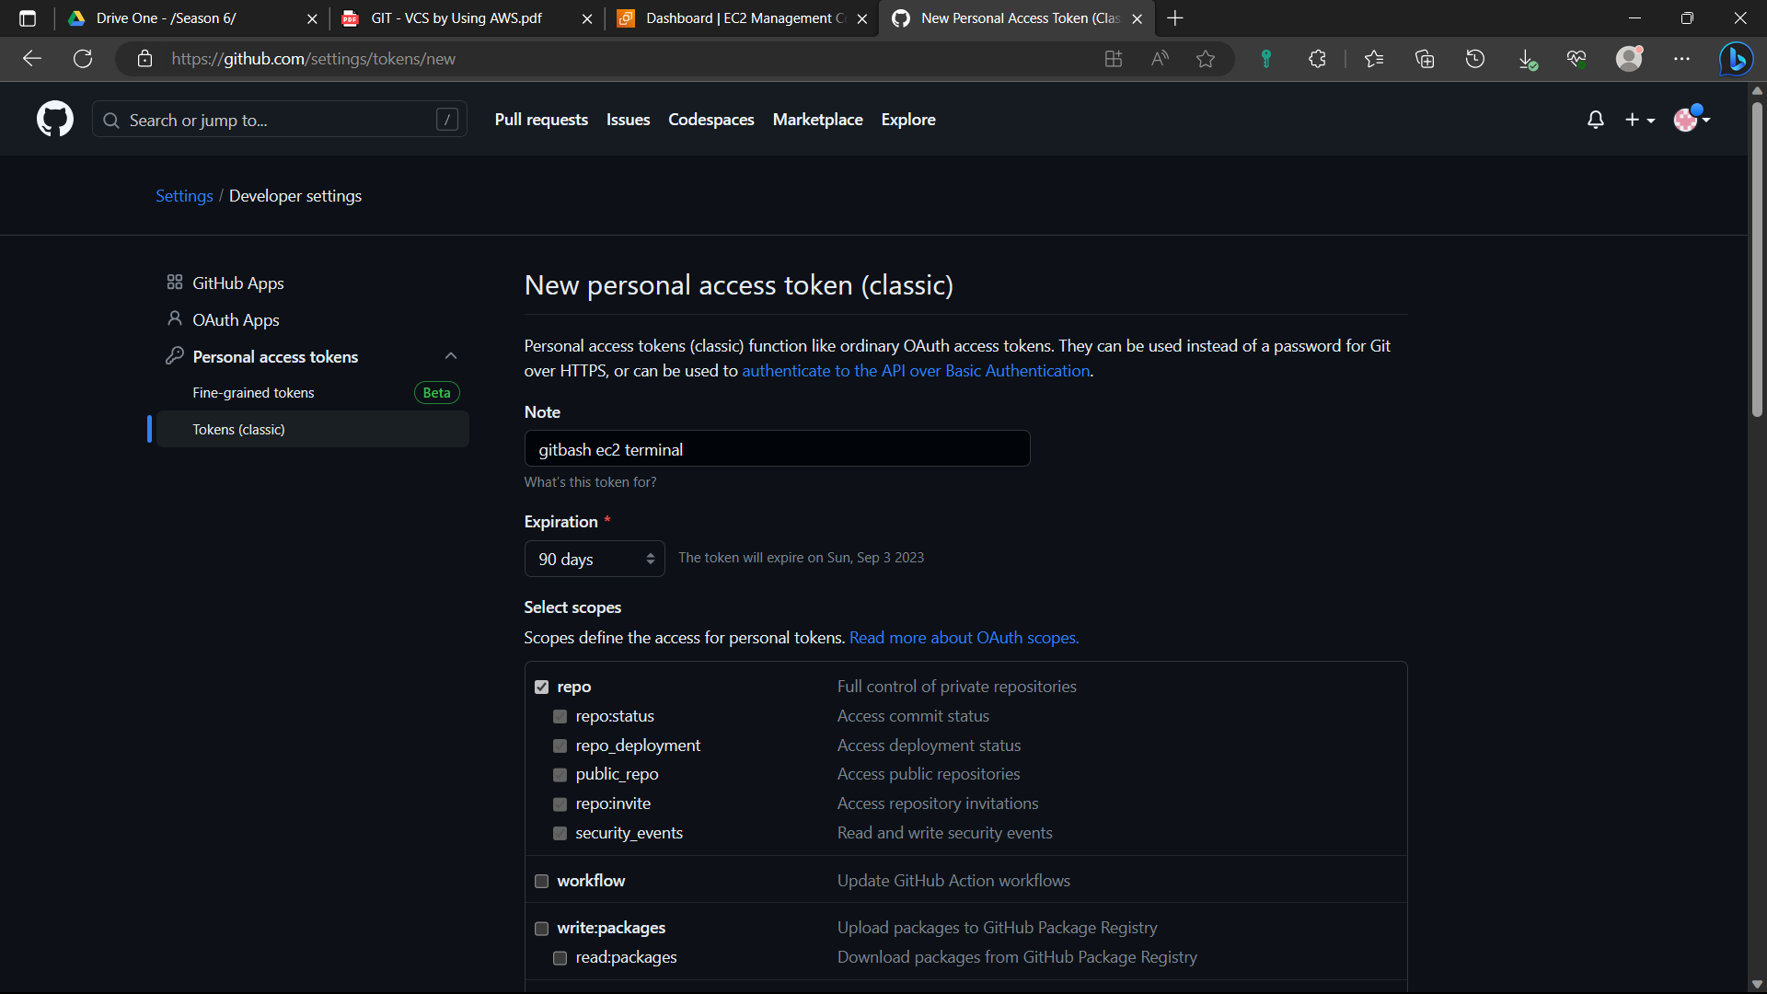

30.Now click on generate token.

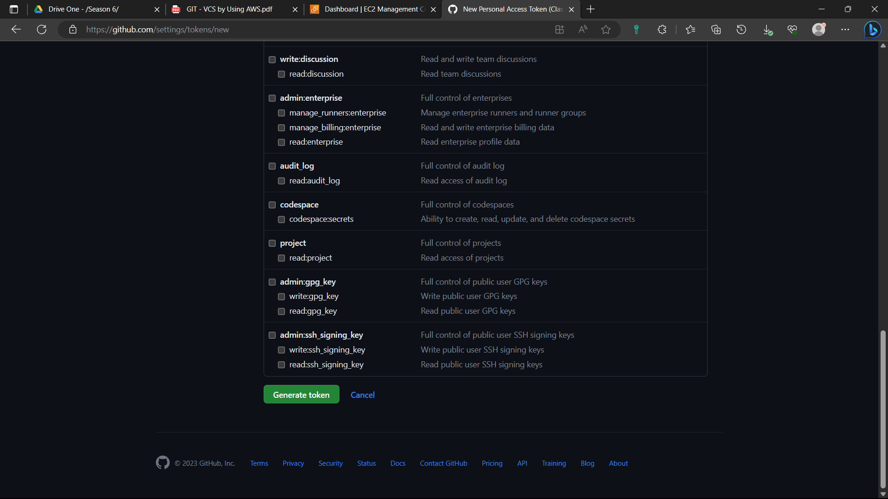

31.Now the token is generated. Copy the private key store it in a safe place at a local host.

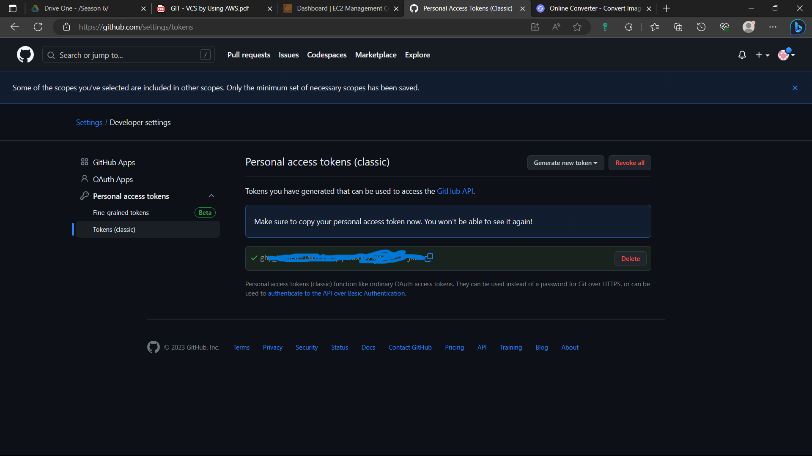

32.Now click on your repositories.

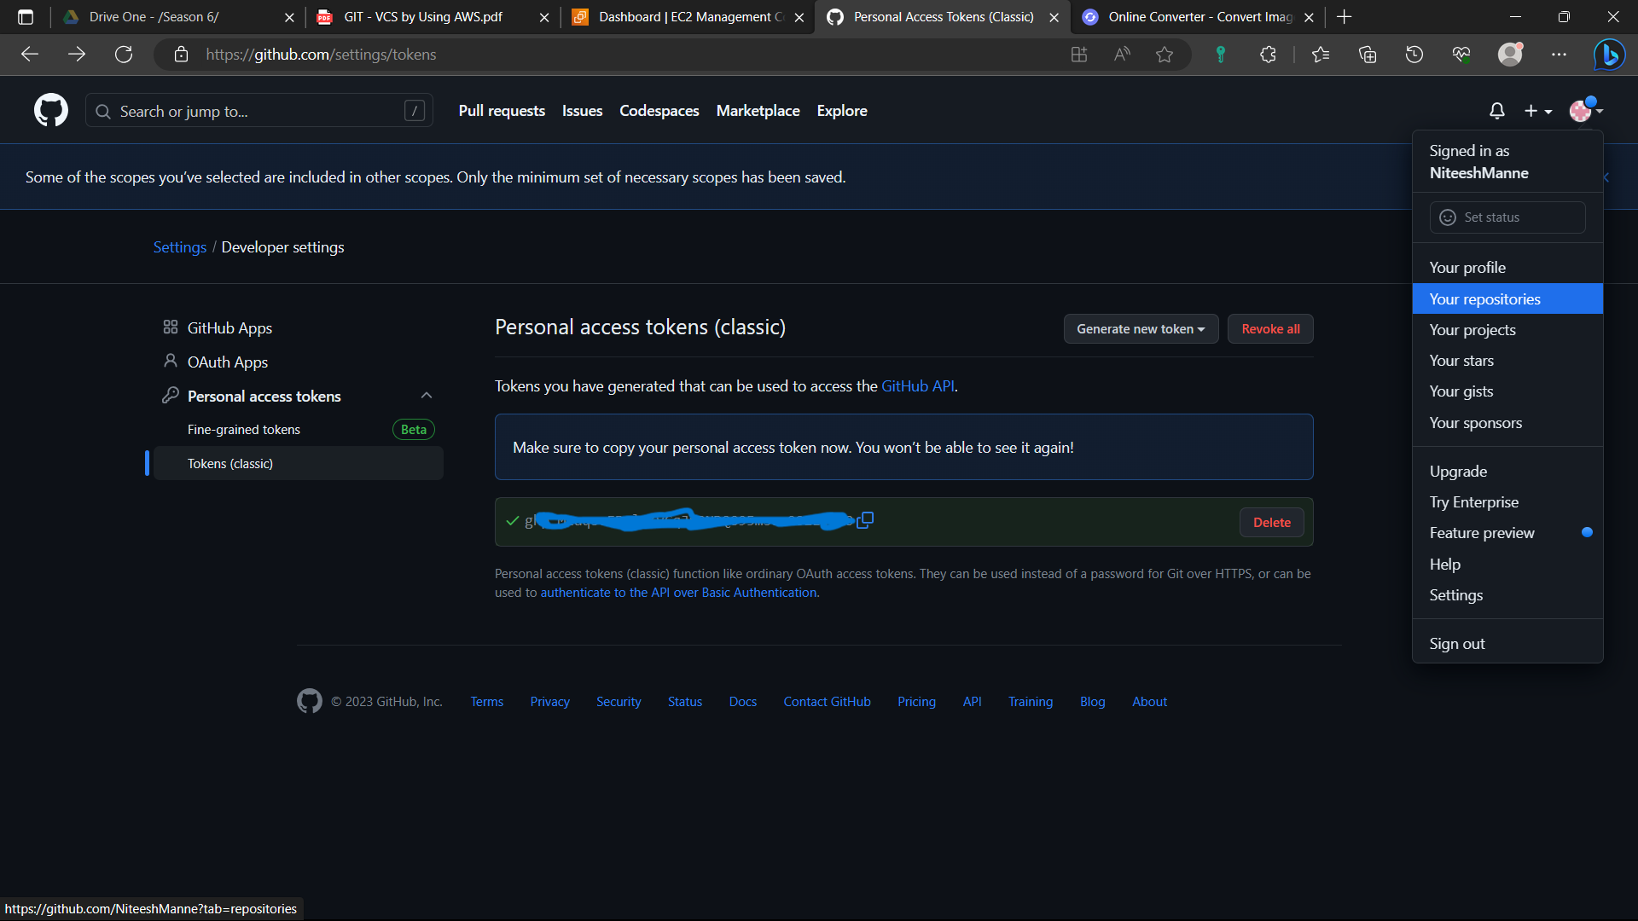

33.Open the repository you created.

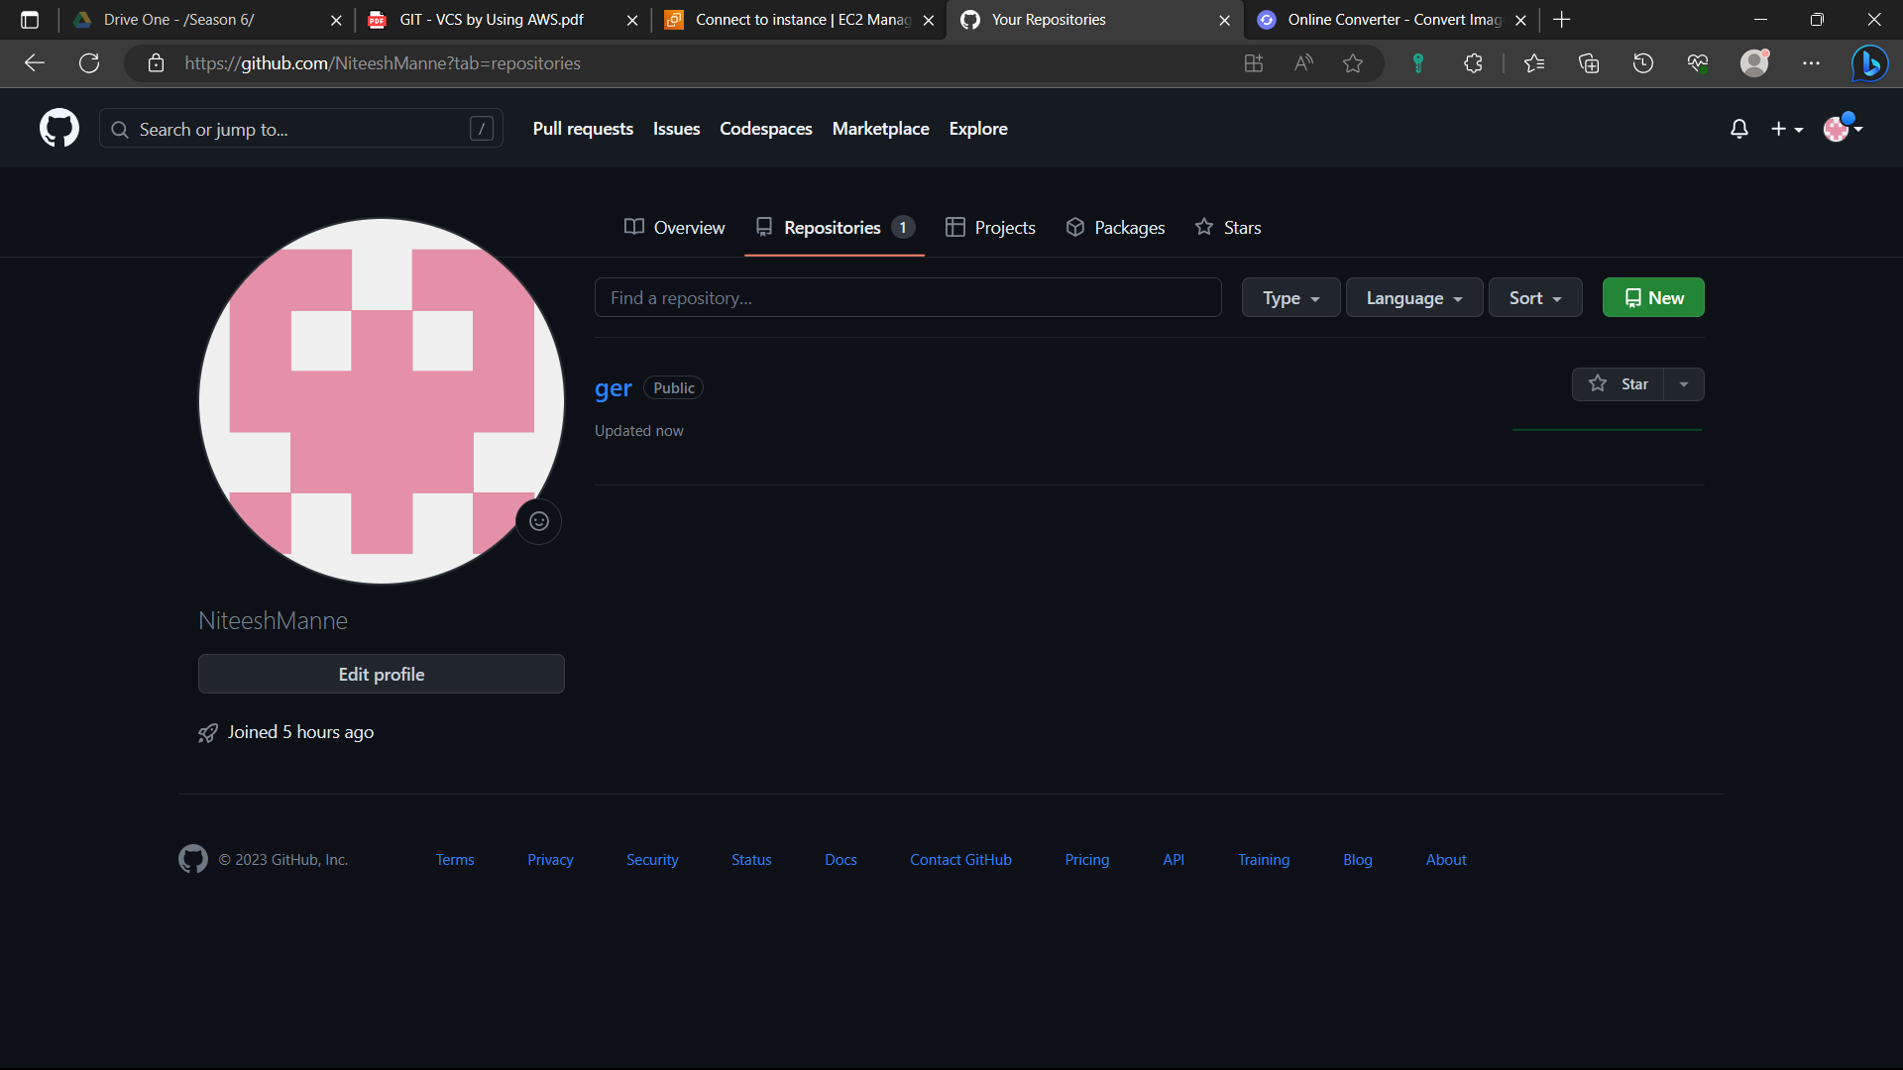

34.Open ger file in repository and copy the https url in the code option.

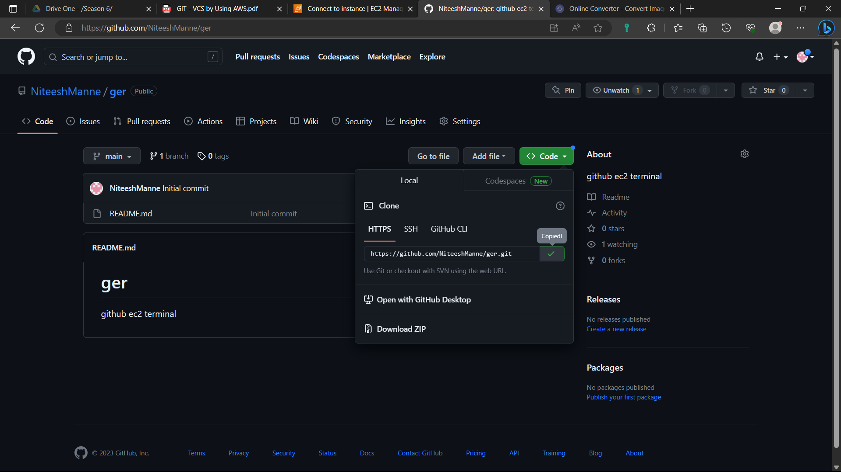

35.Now repeat 10-13 steps to connect to instance.

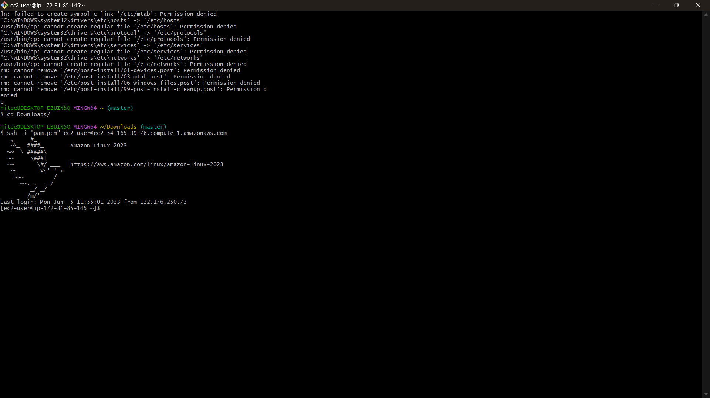

36.Now type the command- “sudo git clone url” - “sudo git clone <https://github.com/NiteeshManne/ger.git>”

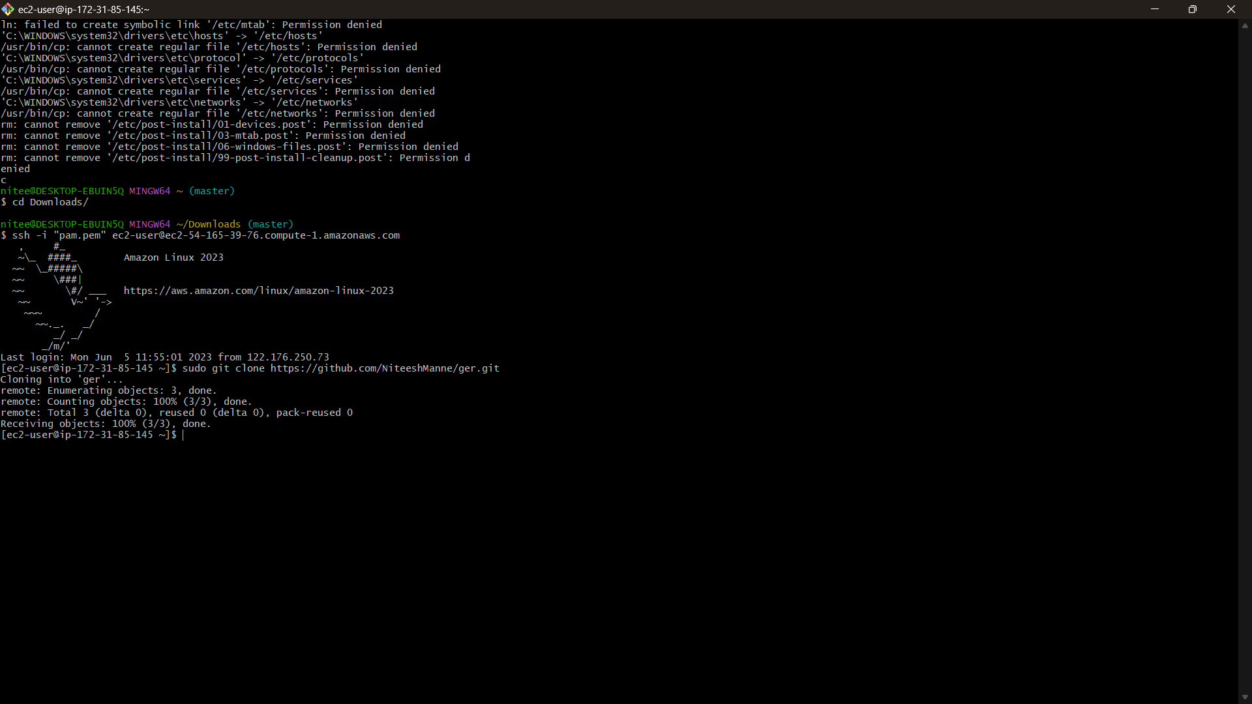

37.Now create some files in the environment after cloning by using the command- “touch <filename>” – “touch ”. Check it by using the “ls” command.

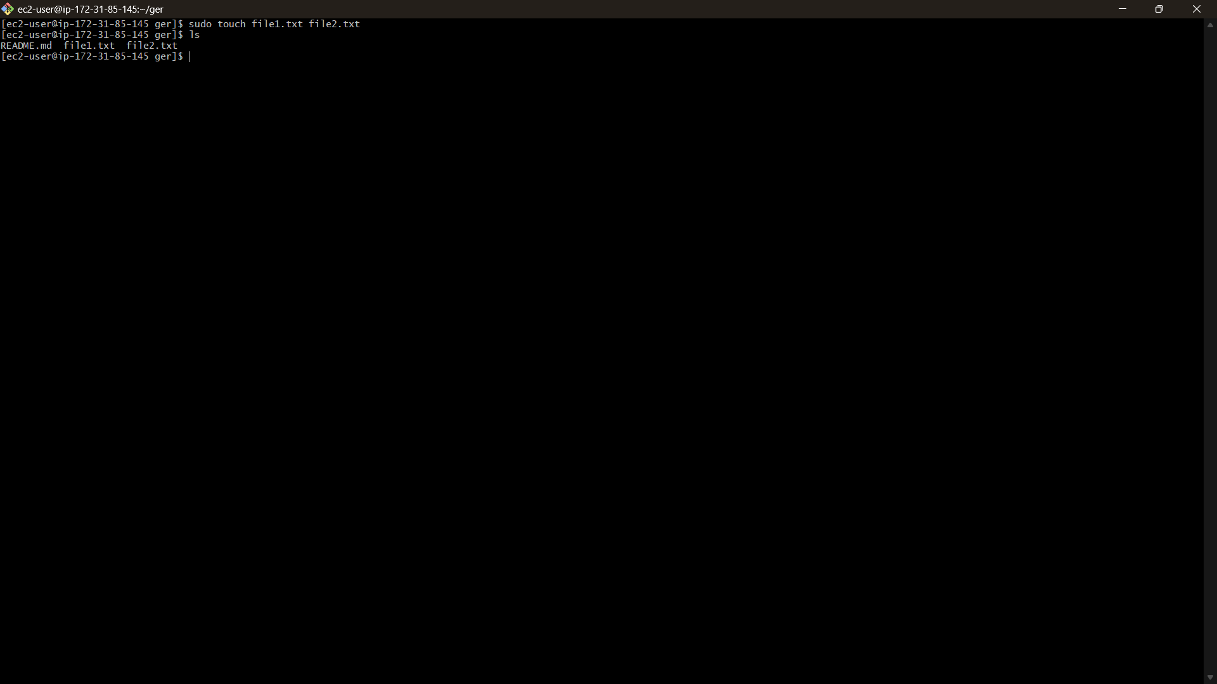

38.To track the file by git we have to these files to staging area.Command – “git add <filename>” - “git add file1.txt file2.txt”.we can check it by using “git status” command.

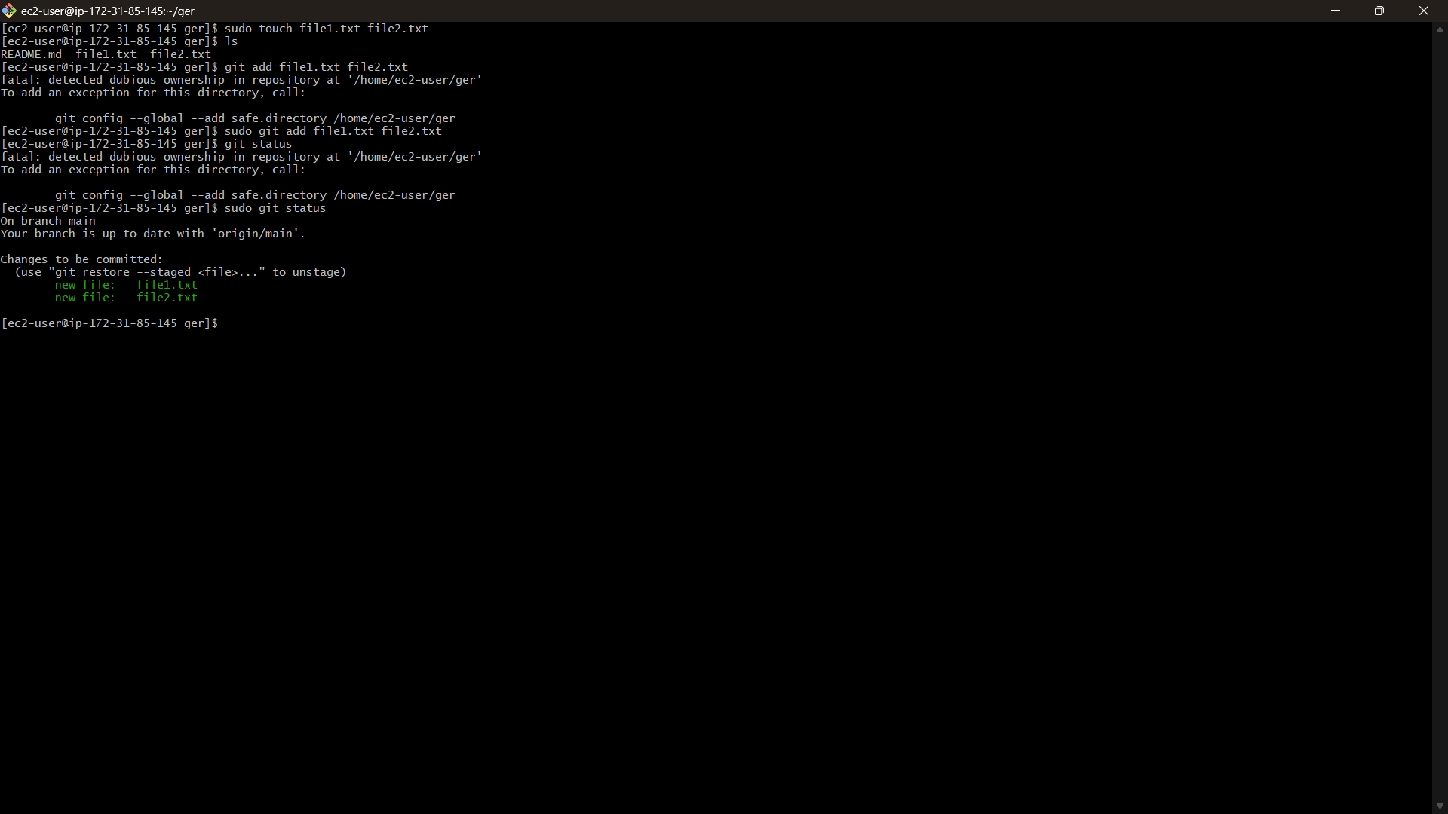

39.Now moves commit these files to local repo by using the command - “sudo git commit -m “any message”. check its status.

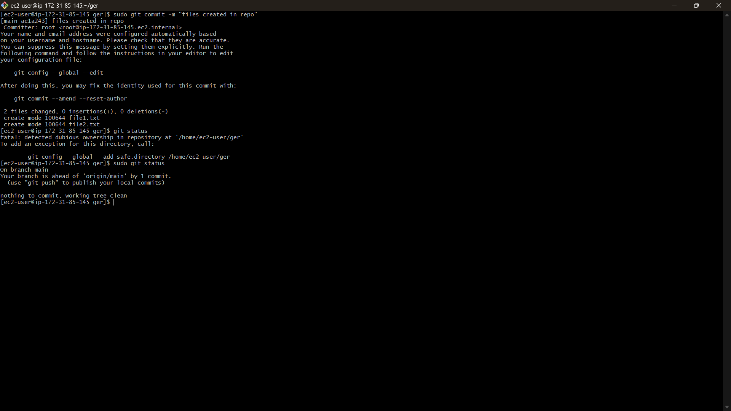

40.Now push the code to github by using the command – “git push -u origin main”. After typing this command it will ask for username and password. Copy and paste your token in both username and password.

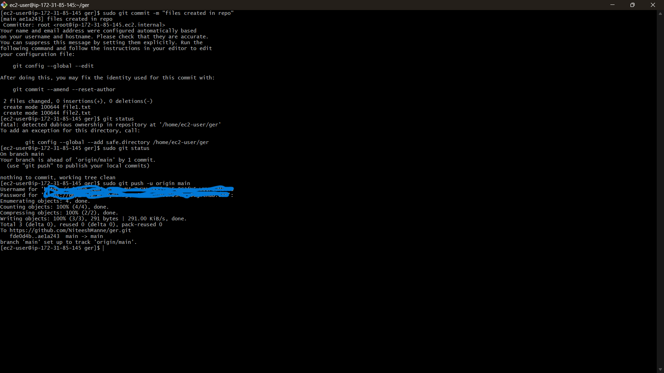

41.Now the files have been to pushed to the github. Check it in your github repository you given in the terminal.

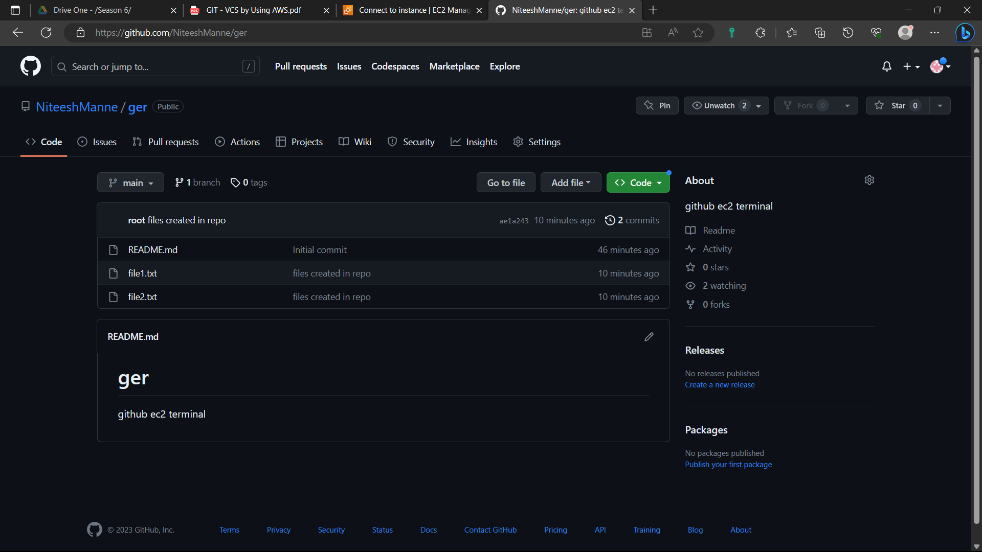

42.Now create a new remote repository in github by clicking on new.

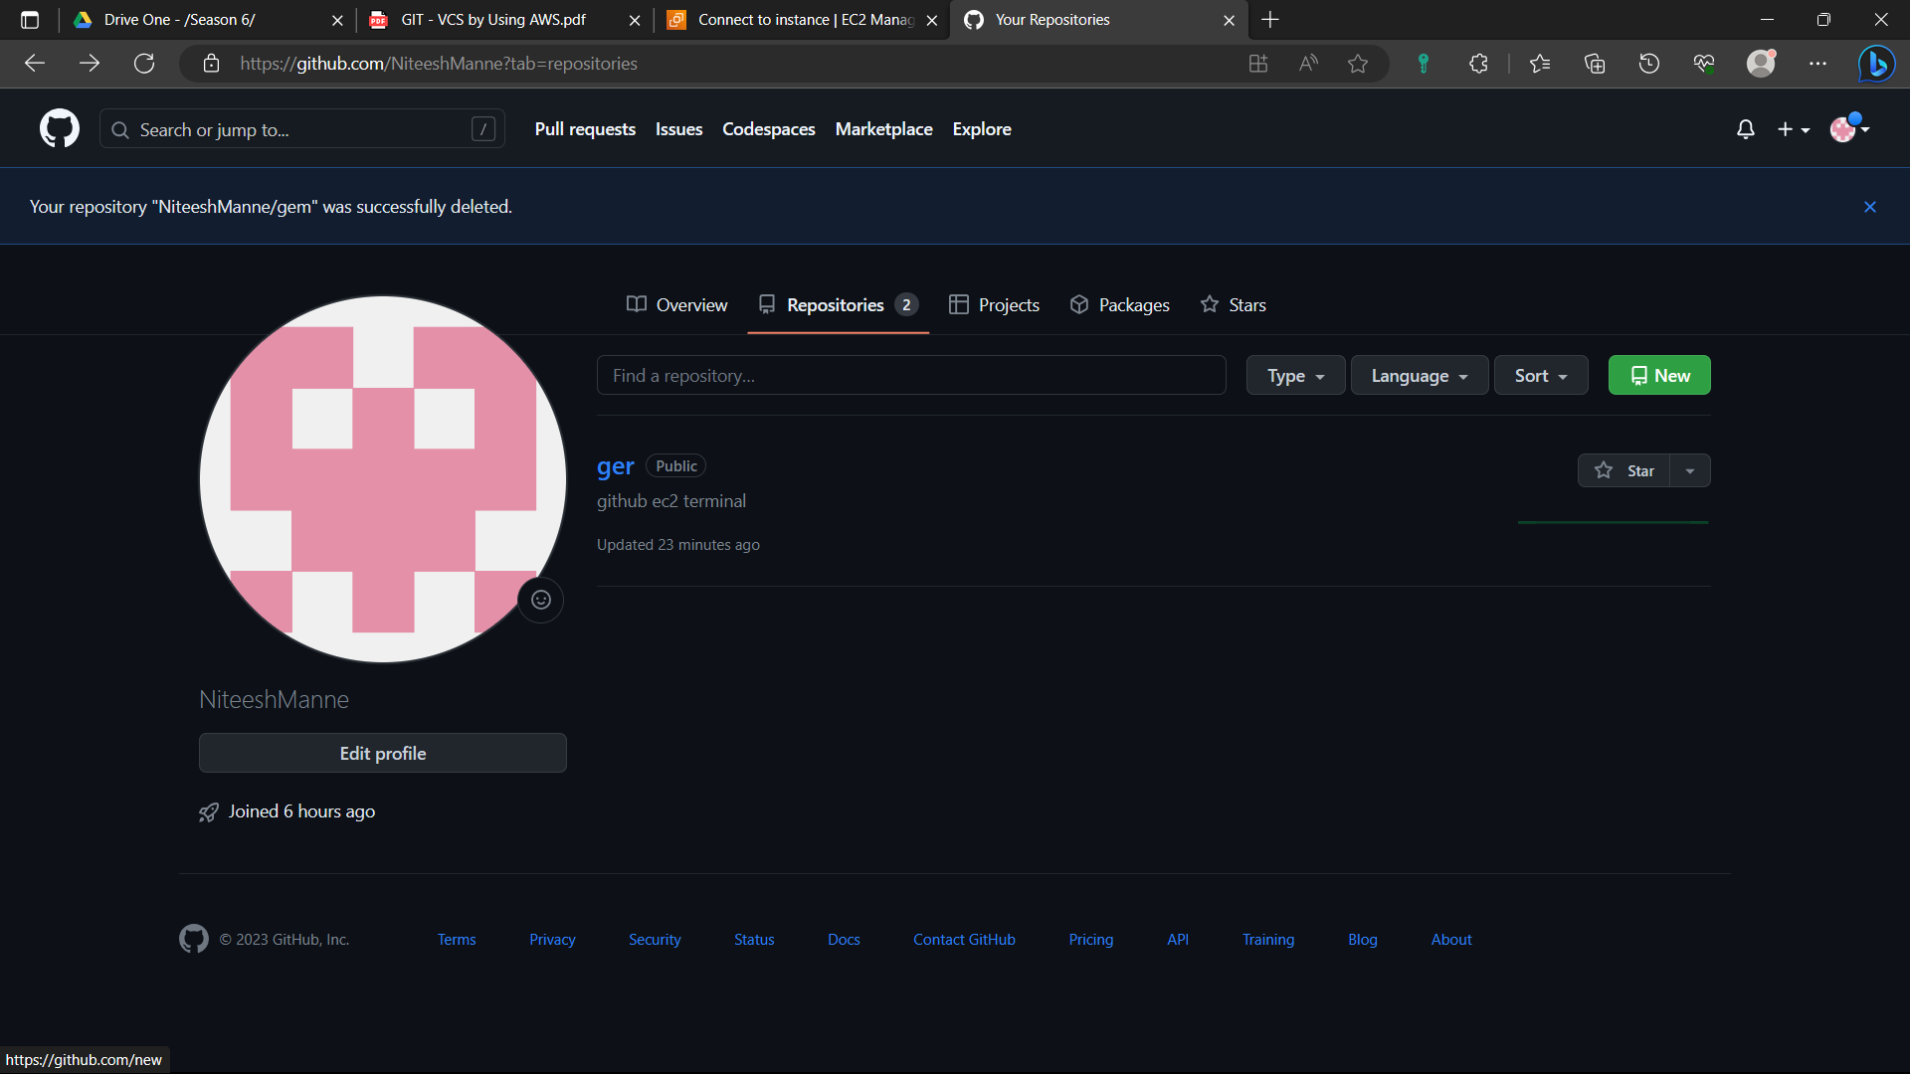

43.Give a name and enable public file and click one create repository option.

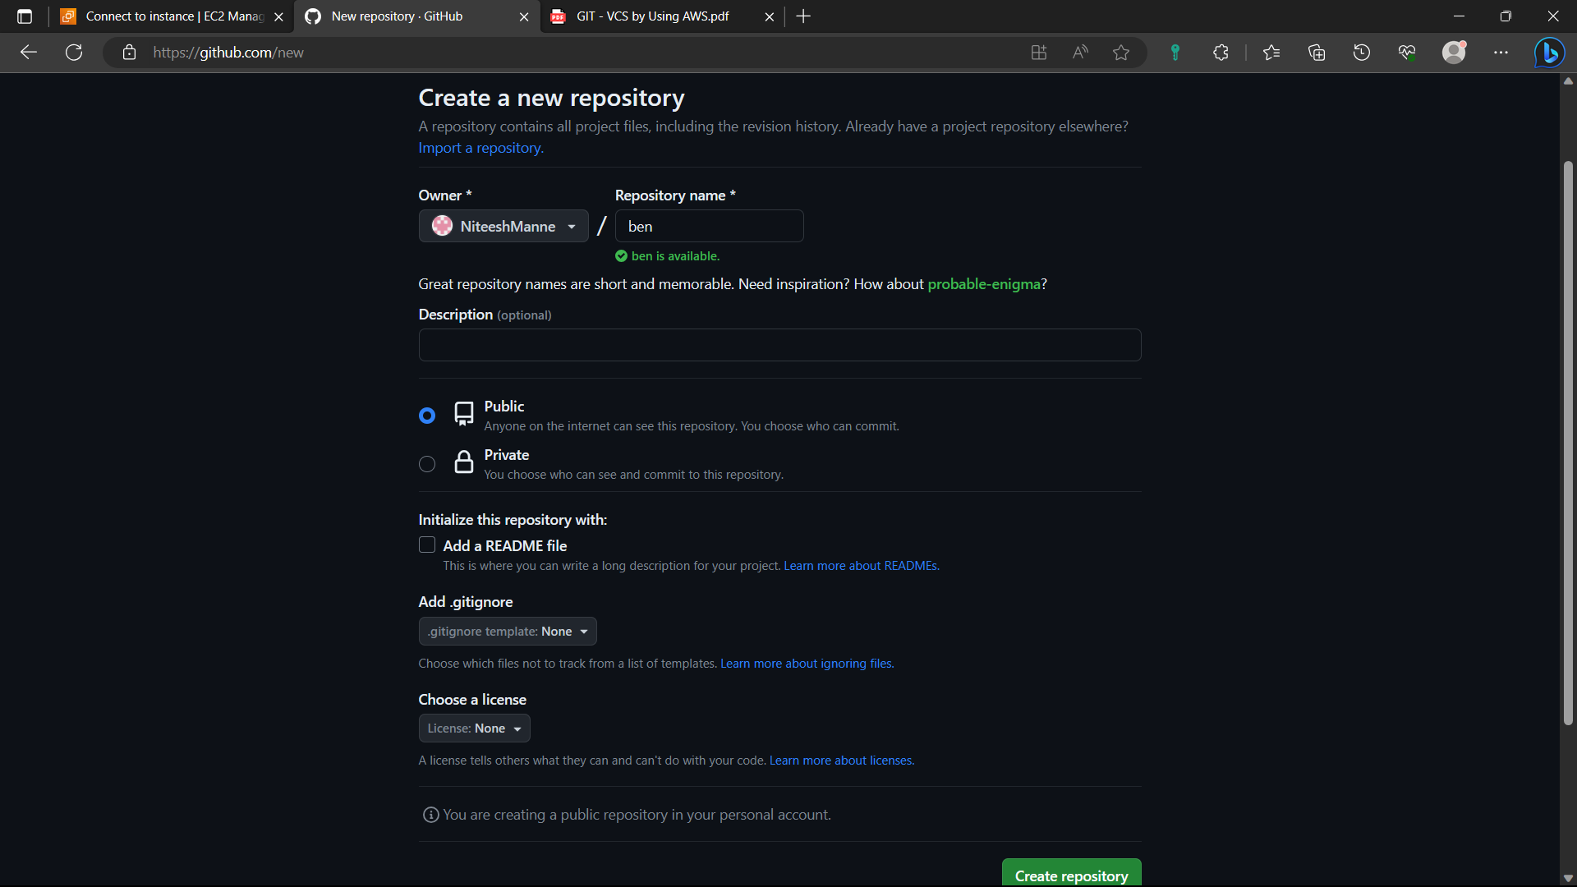

44.Now the repository is created.

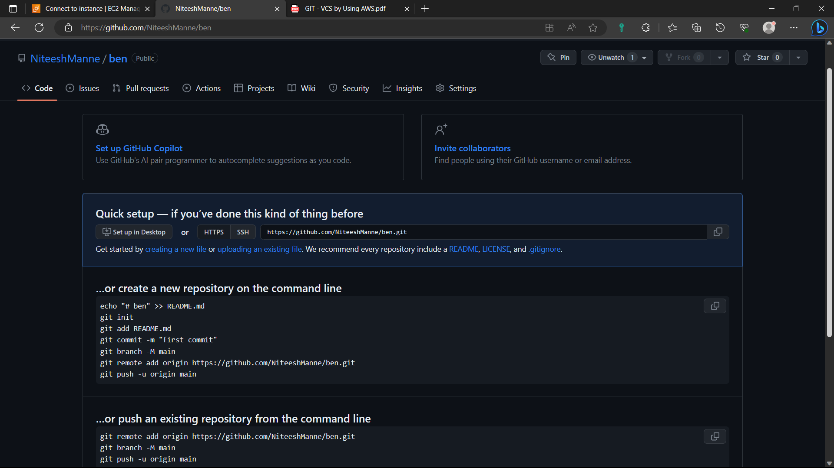

45.Now to come to local machine navigate the repository created in “steps 15-21” by using the command “cd <foldername>”.



46.Type the command “git branch -M main” : It will change the name of the branch from master branch to main branch.

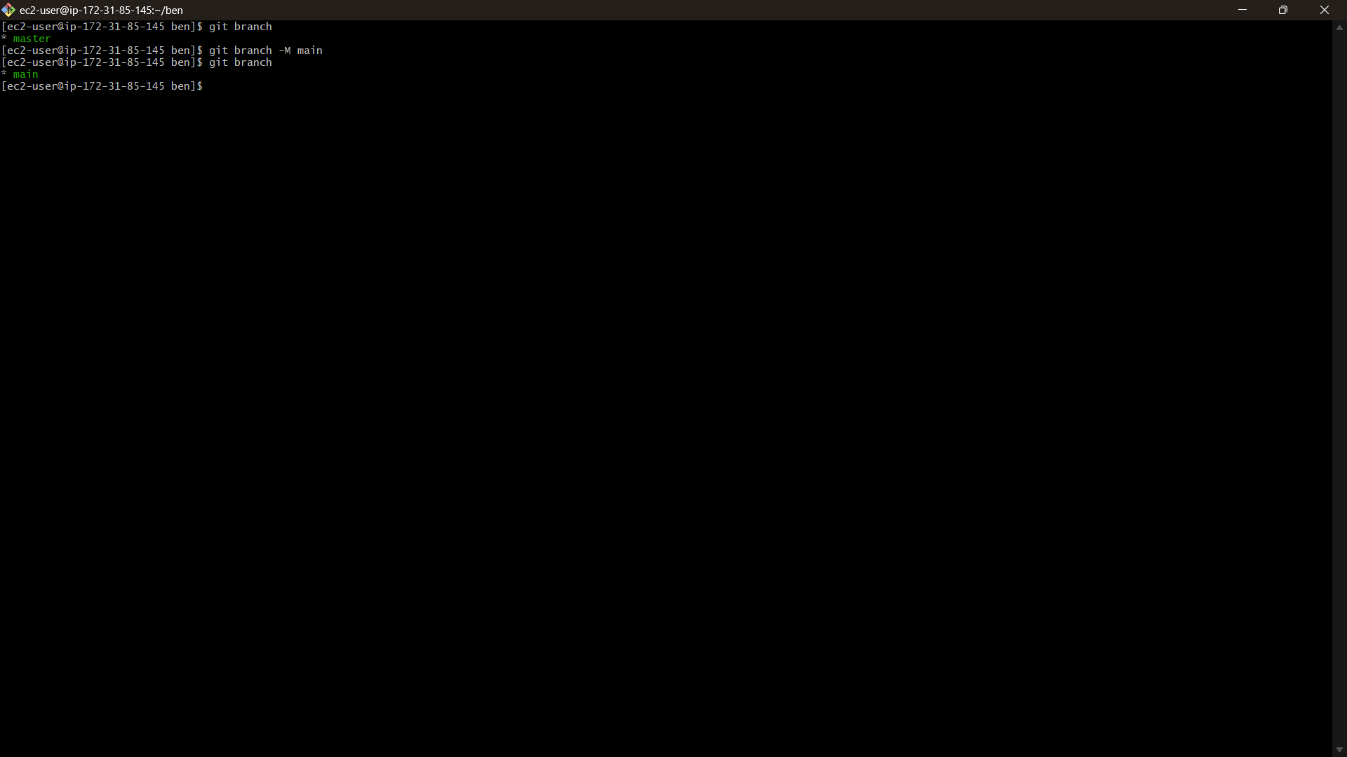

47.Now type the command “git remote add origin <remote repo url>”.It is used to create a local copy of central repository.

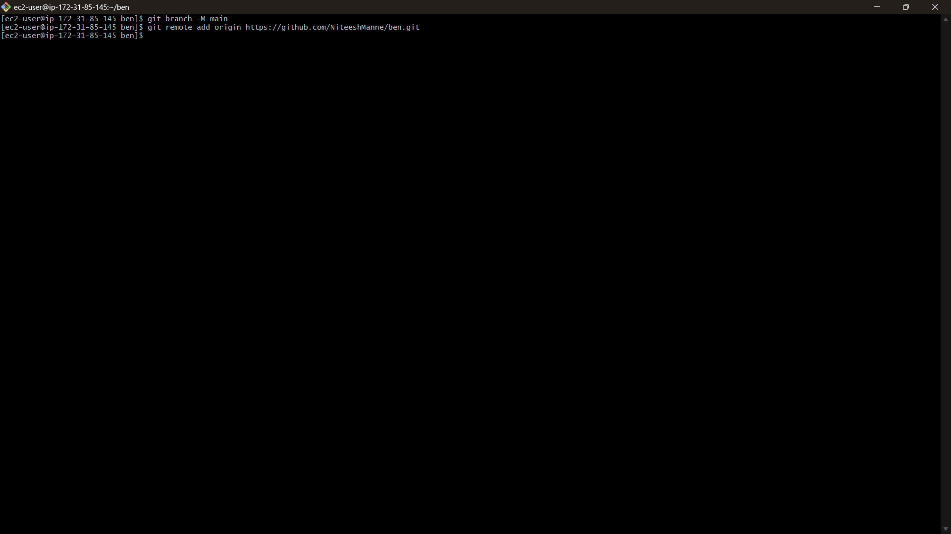

48.Now push your local to remote repo using the command – “git push -u origin main”. It will ask for username and password paste the private token.

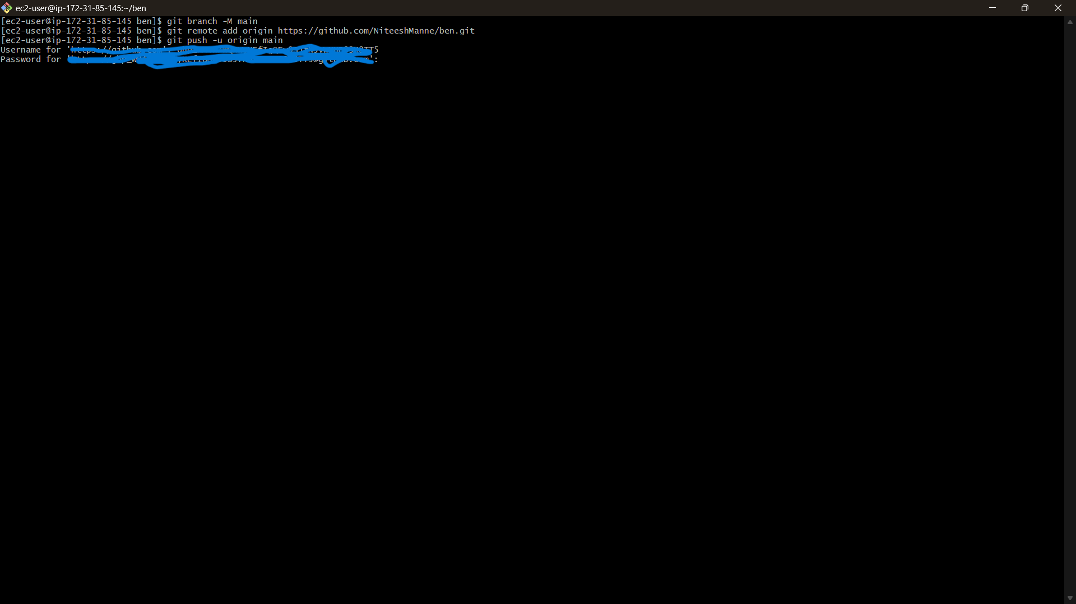

49.Now the files are pushed to the github.

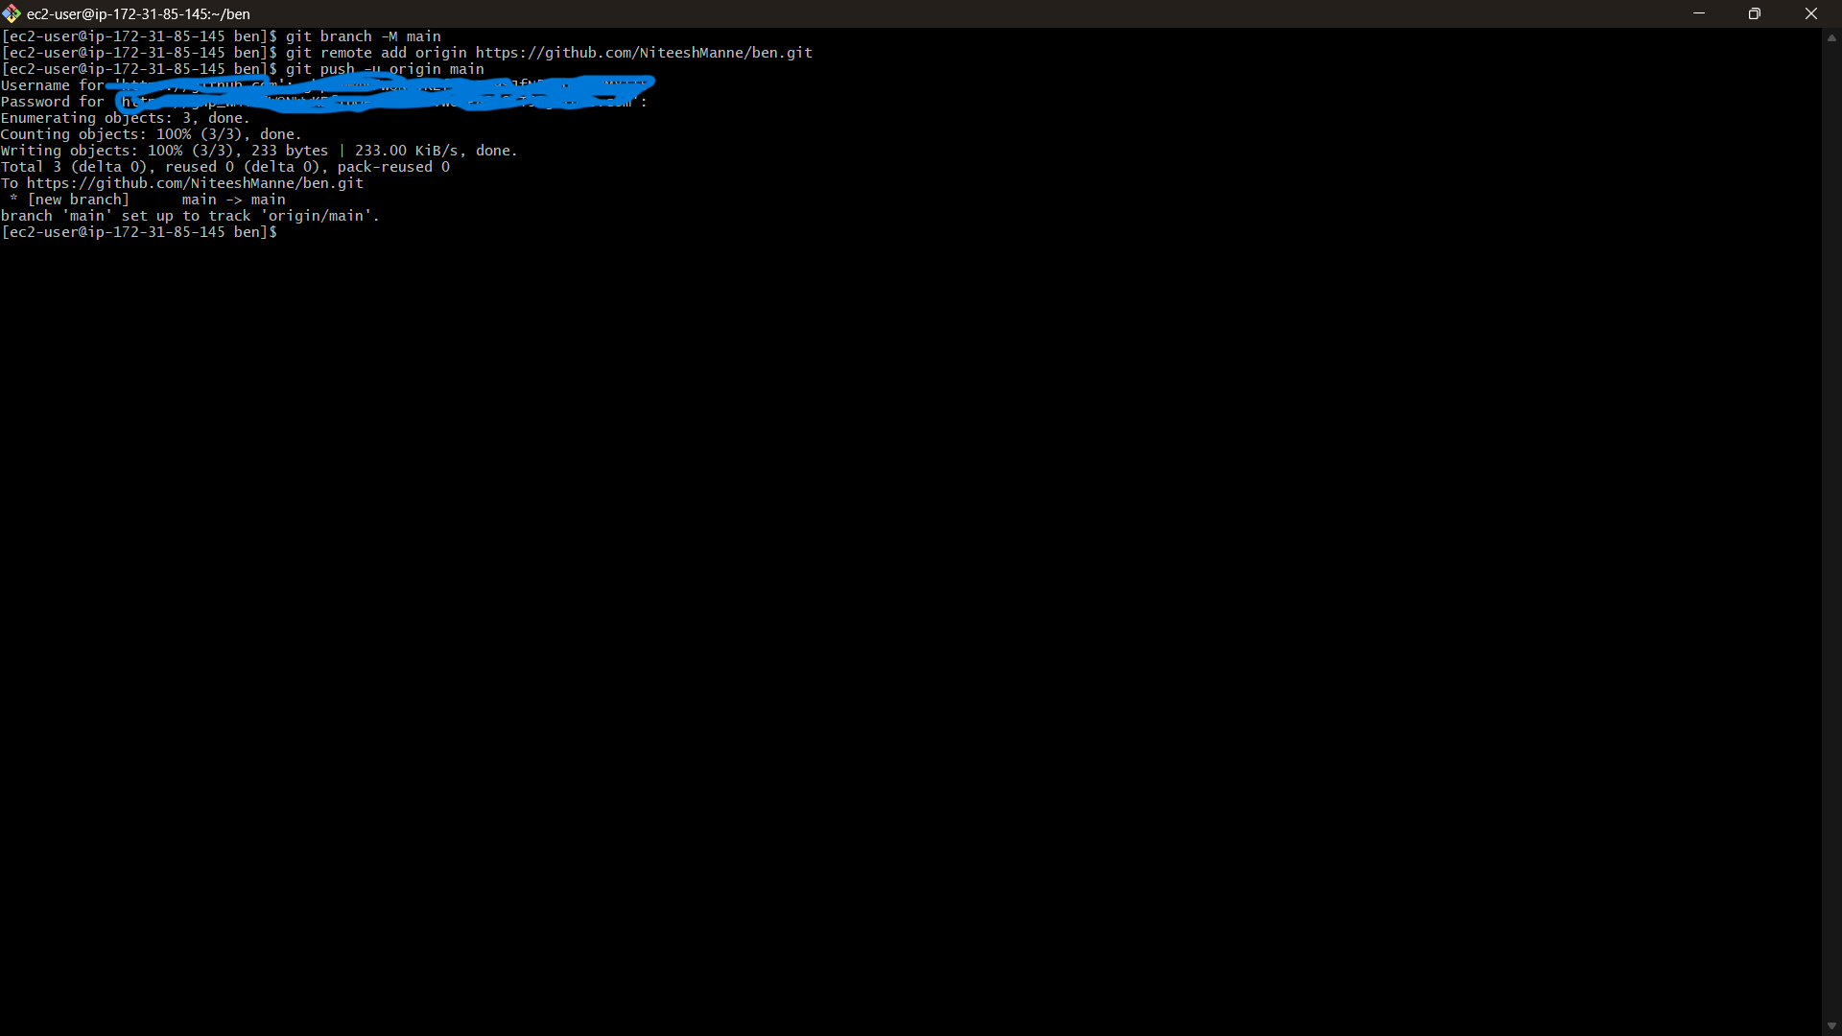

50.Nowrefresh the github page, we can see the files in the github repository.

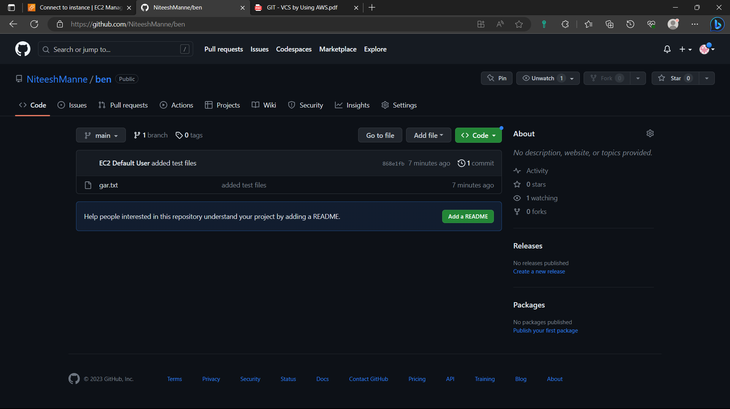

51.At the repository click the main option, then we see the branch below it there is an option view all branches click it.

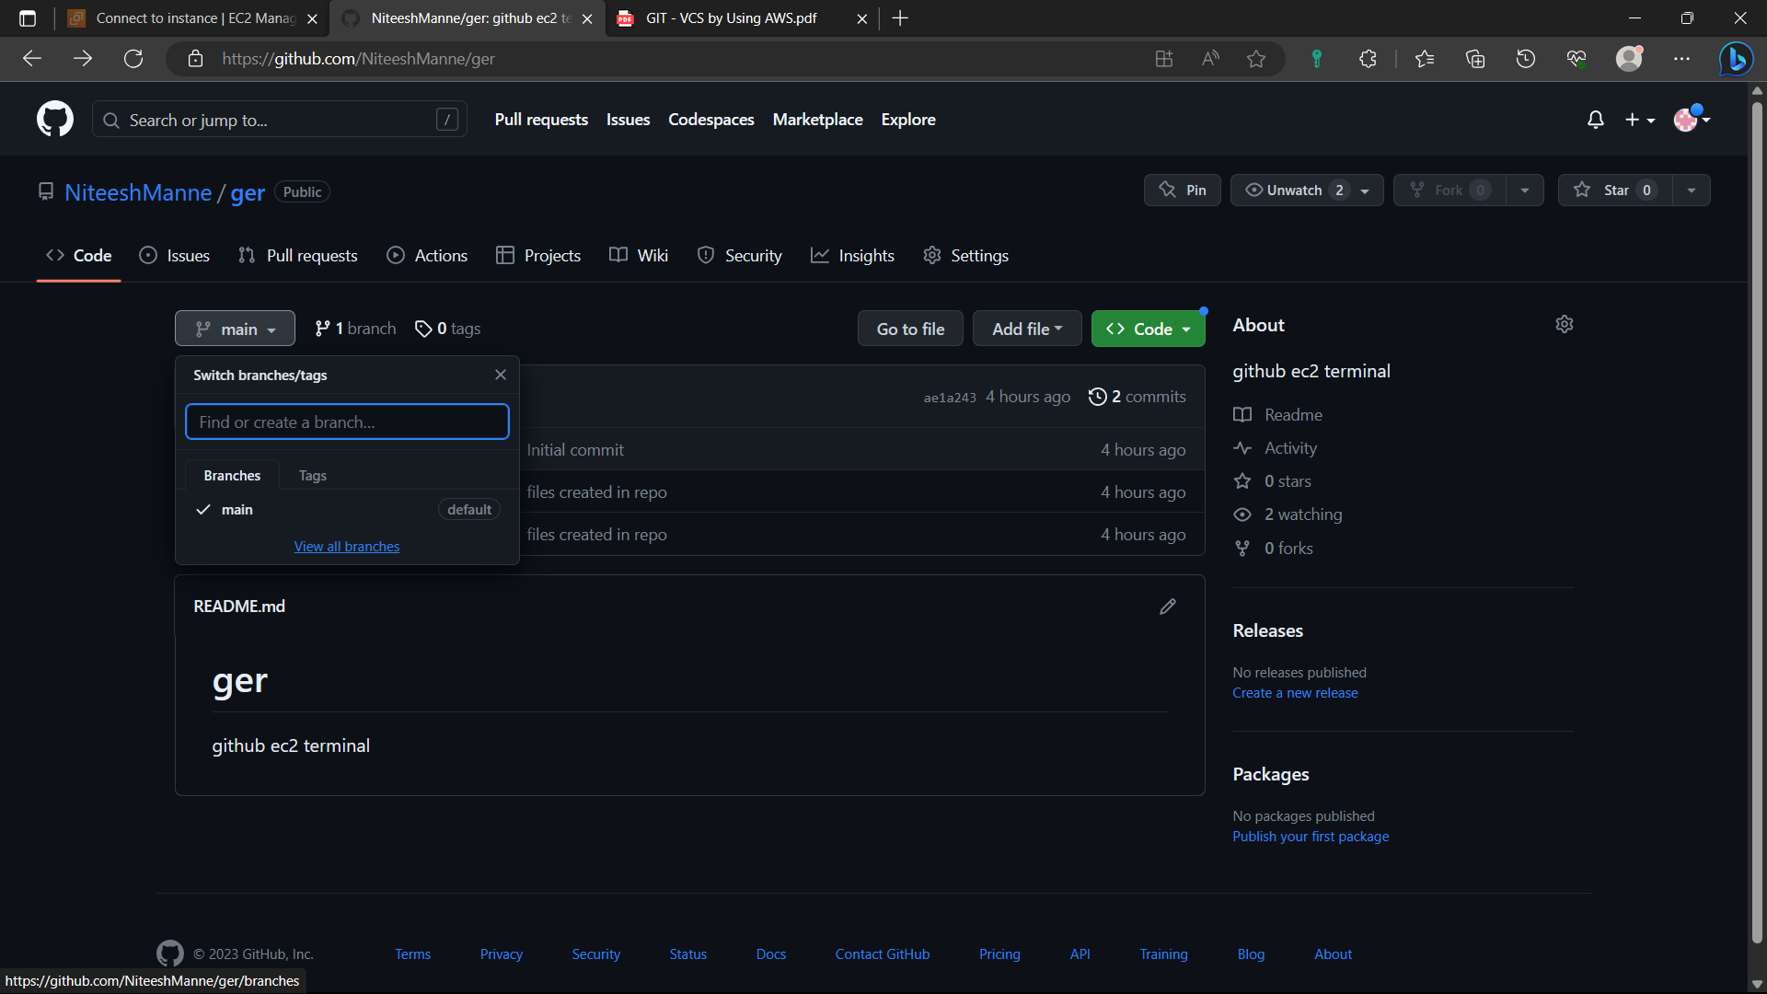

52.Click new branch option on the left side.

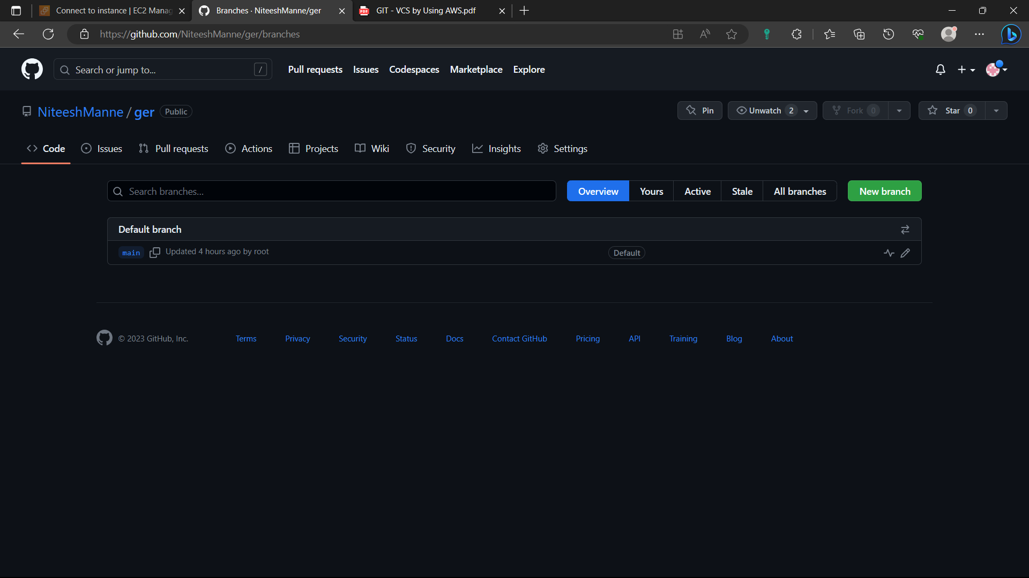

53.Give a name to the branch and click on create new branch.

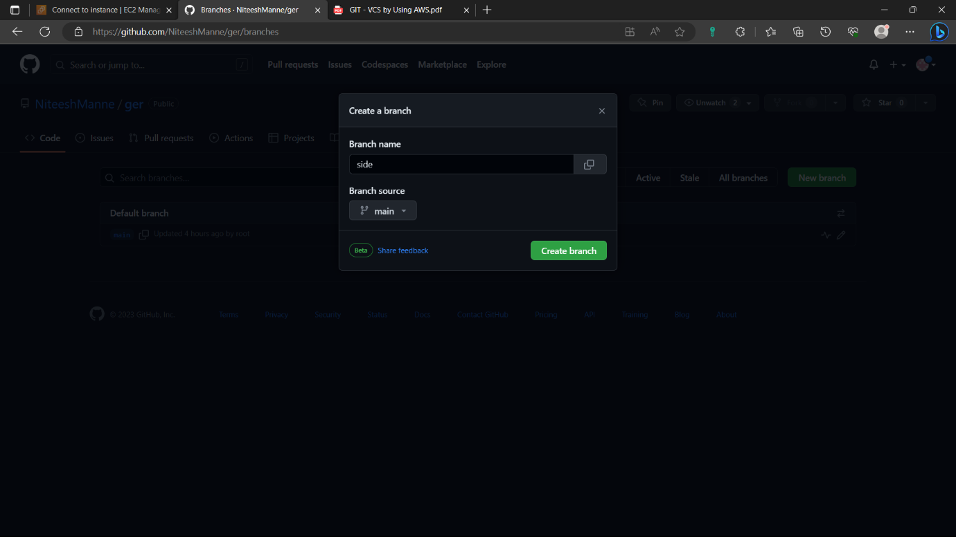

54.Now the branch is created.

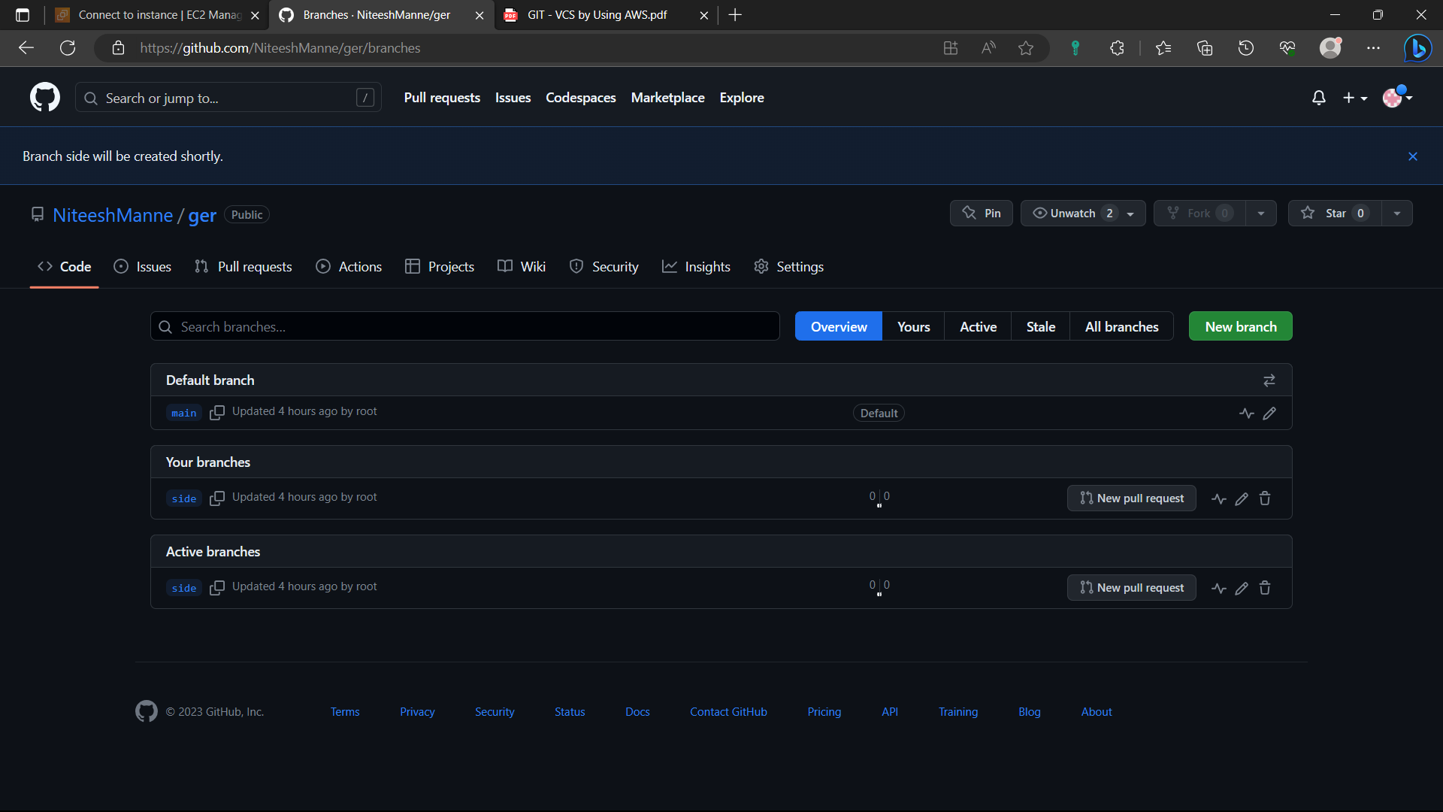

55.Now to go to the local repo where you have the copy of the ger repository.

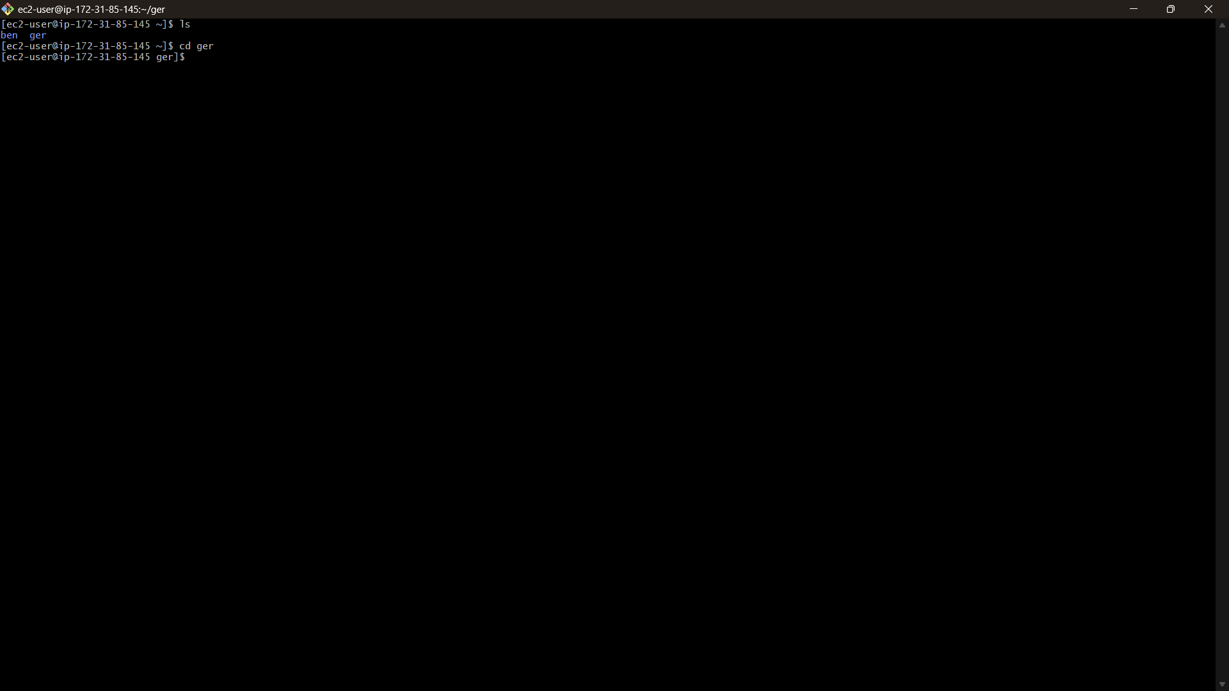

56.Now type the command “git config --global –add safe.directory /home/ec2-user/ger”, if there is an error while using the git pull command.

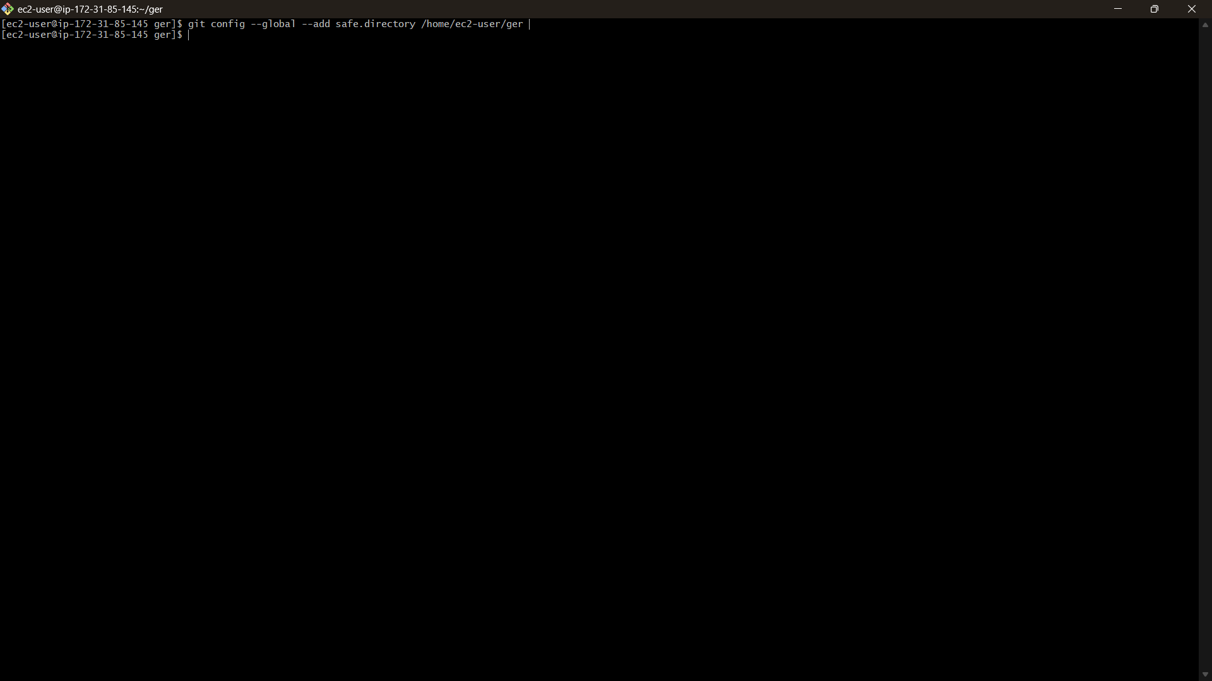

57.Now type the command – “git pull” : it will pull all the latest changes made in github including the new branches created to local repository.

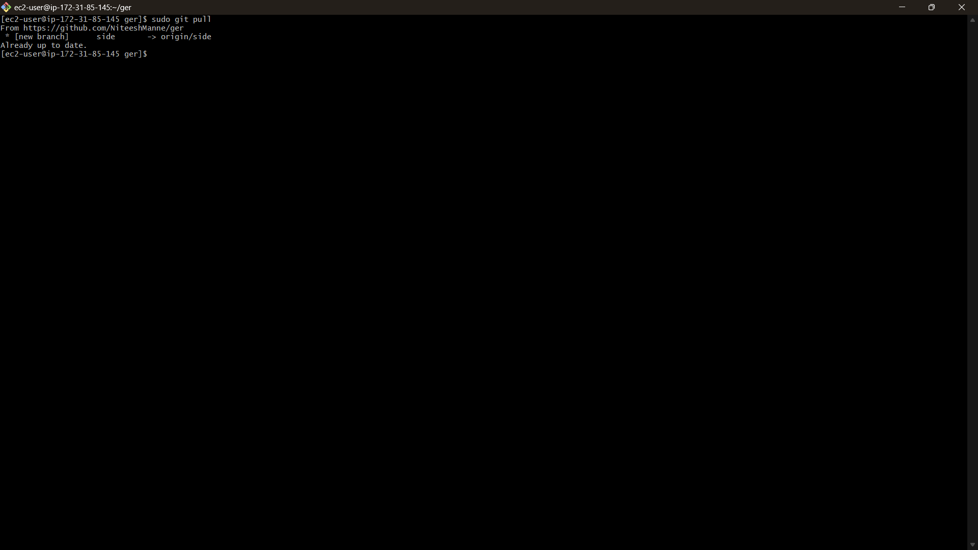

58. “git branches -a”: lists down all the branches

i)Branches with remote are remote branches

ii)branches without remote are available on you local as copy also.

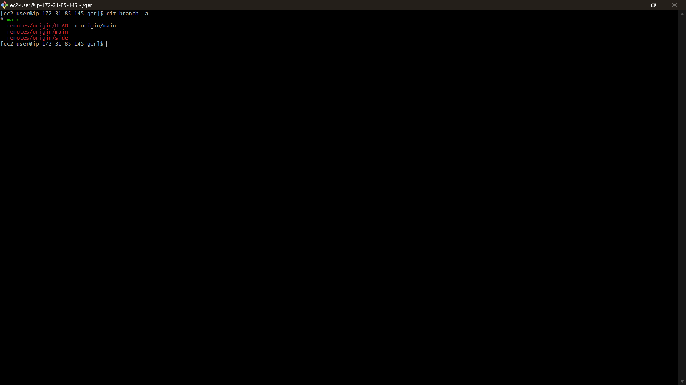

59.Now use the command “git checkout <branchname>” - “git checkout side” will switch to side branch. Check whether we switched or not by using the command – “git branch”. The branch which the “\*” symbol at the start of branch name, colour=green represents the present branch.

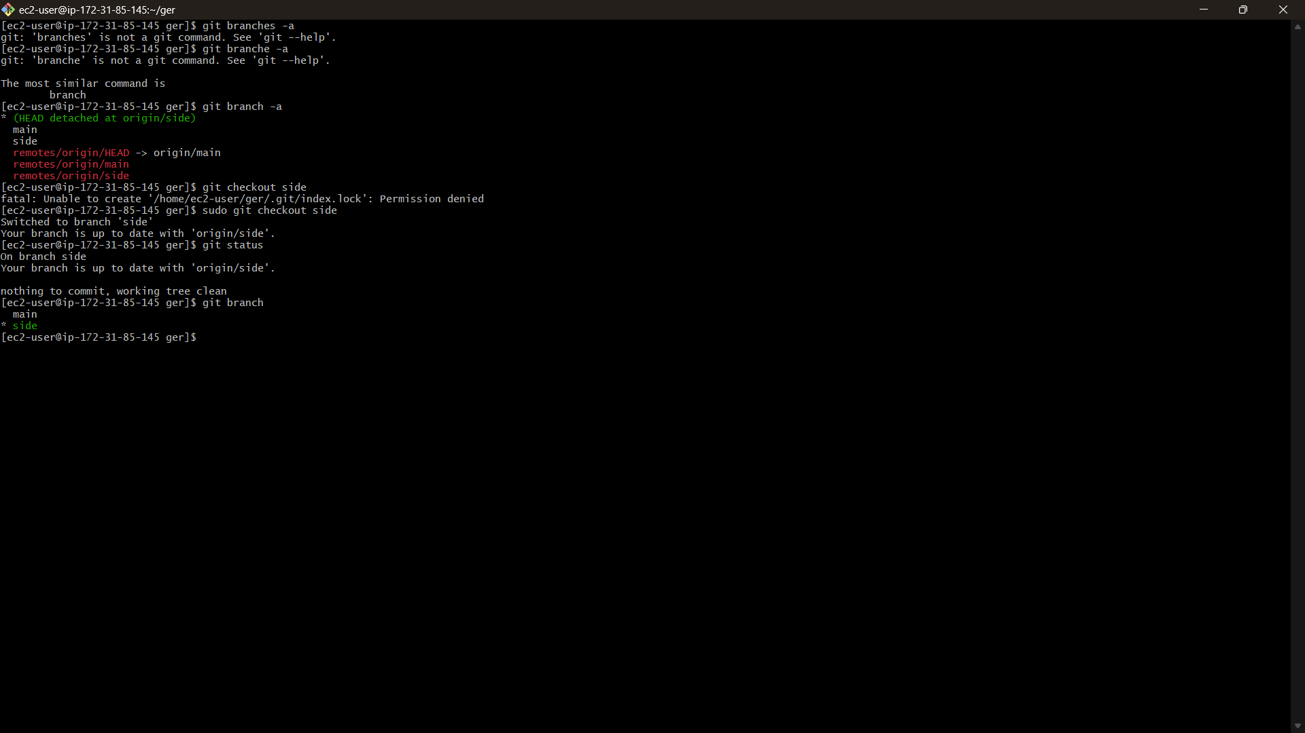

60.now create a file using “sudo touch <filename>”command. the file will be created in side branch only. And check the whether the file is v=created or not by using “ls” command

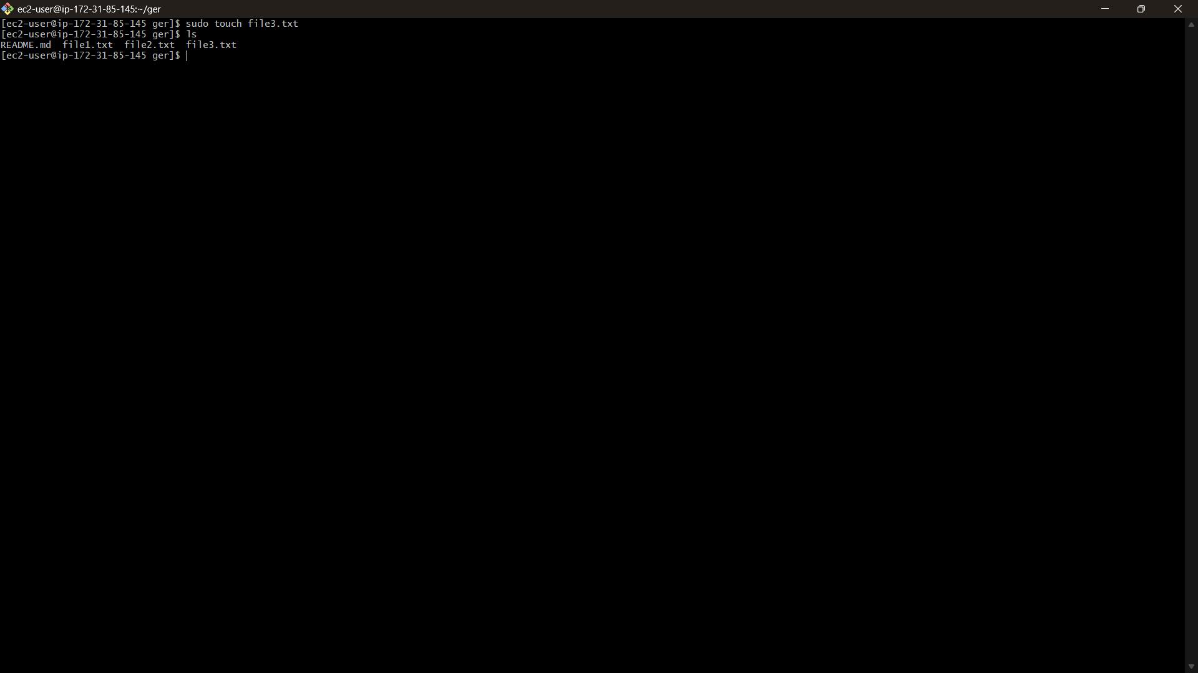

61.Check the git status if the file is in red colour means the file is not currently tracked by git.

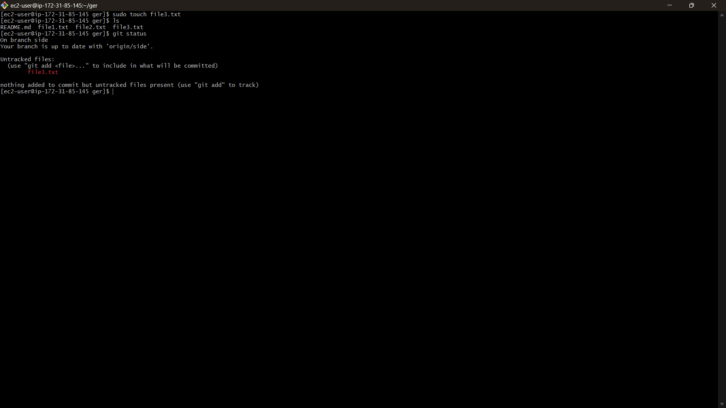

62.command:”sudo git add <filename>” :file will be tracked by git and file move staging area.

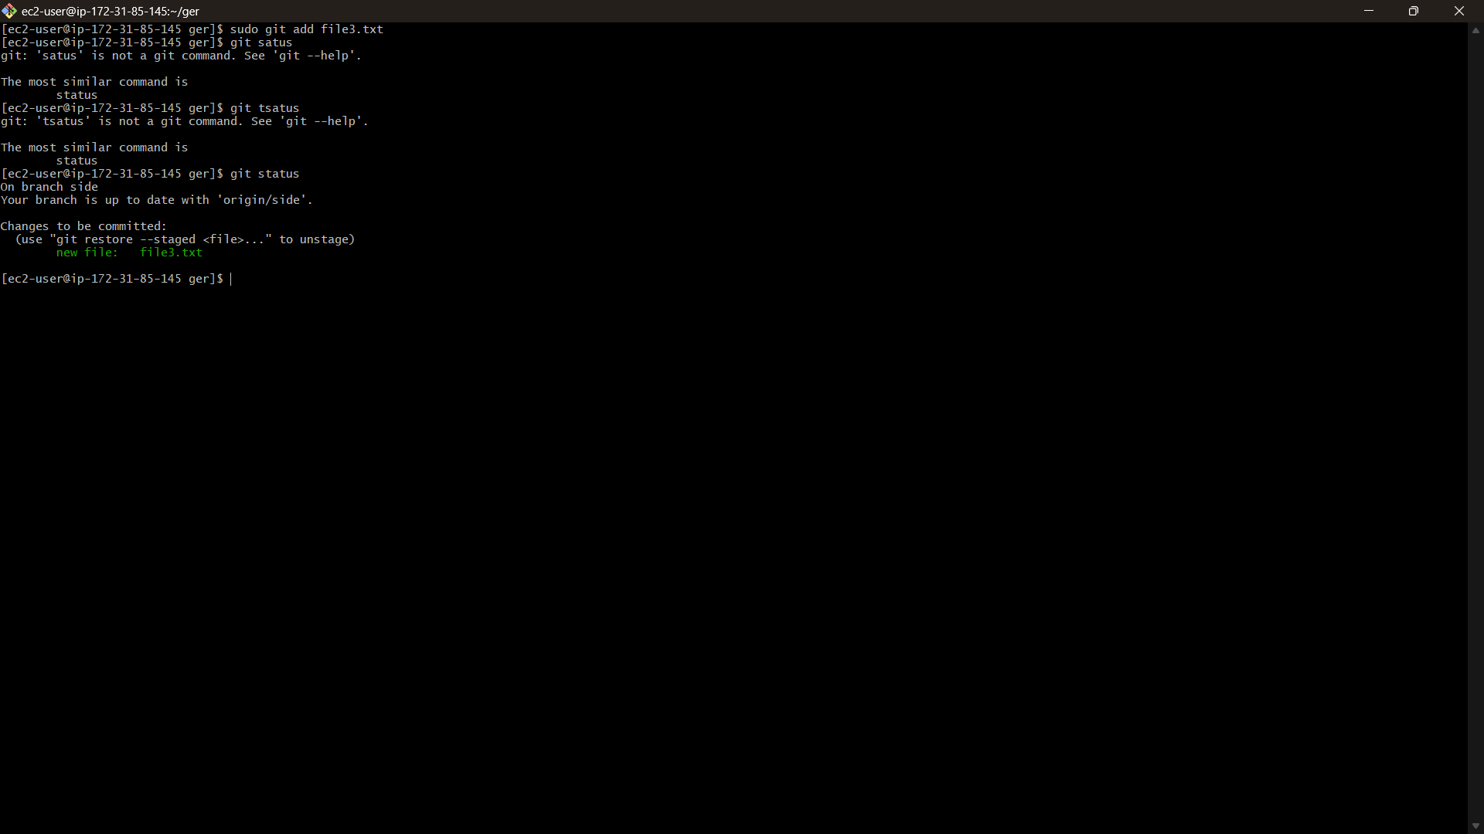

63. ”sudo git commit -m “your message””: moves the file from staging area to local repository.

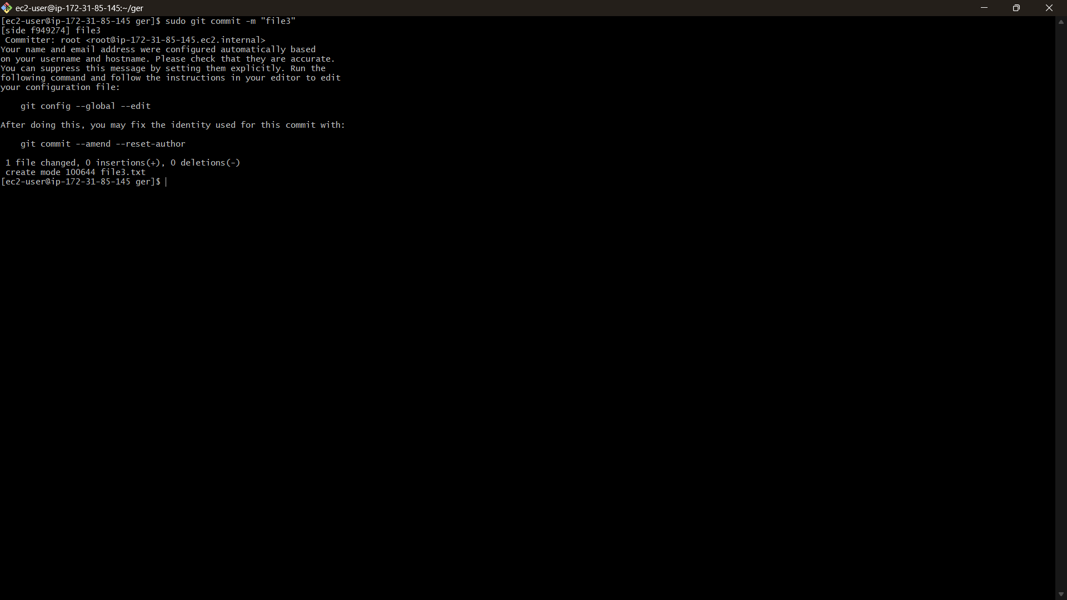

64.Now push the file from local repository to github using the command – “sudo git push”.

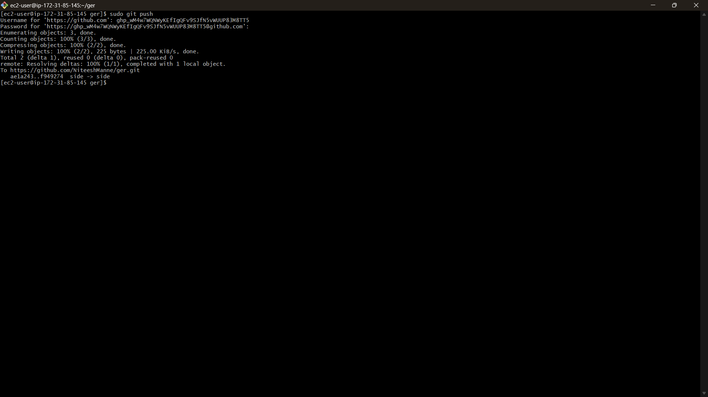

65.Go to github and refresh the page you will see a message the side(created branch) has a push.

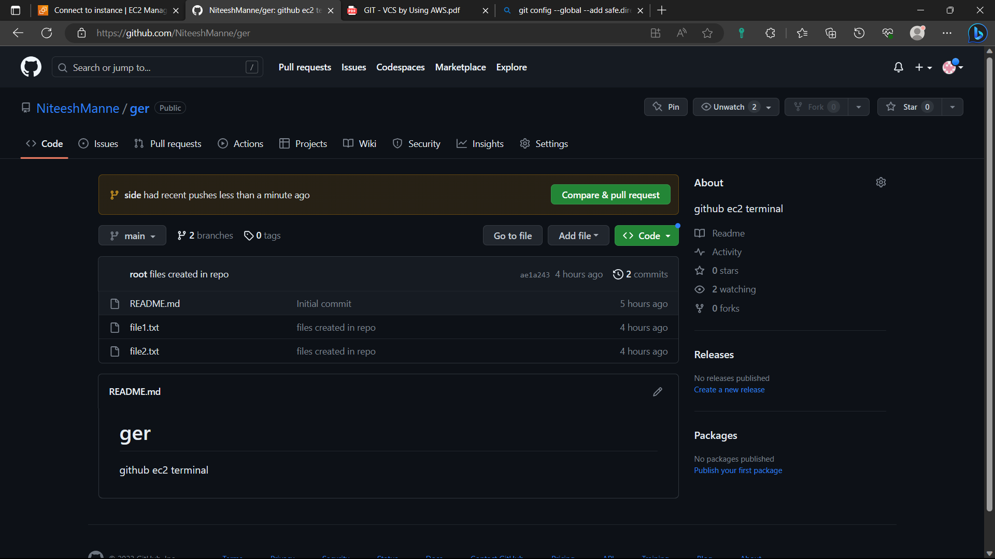

66.Now switch to side branch.

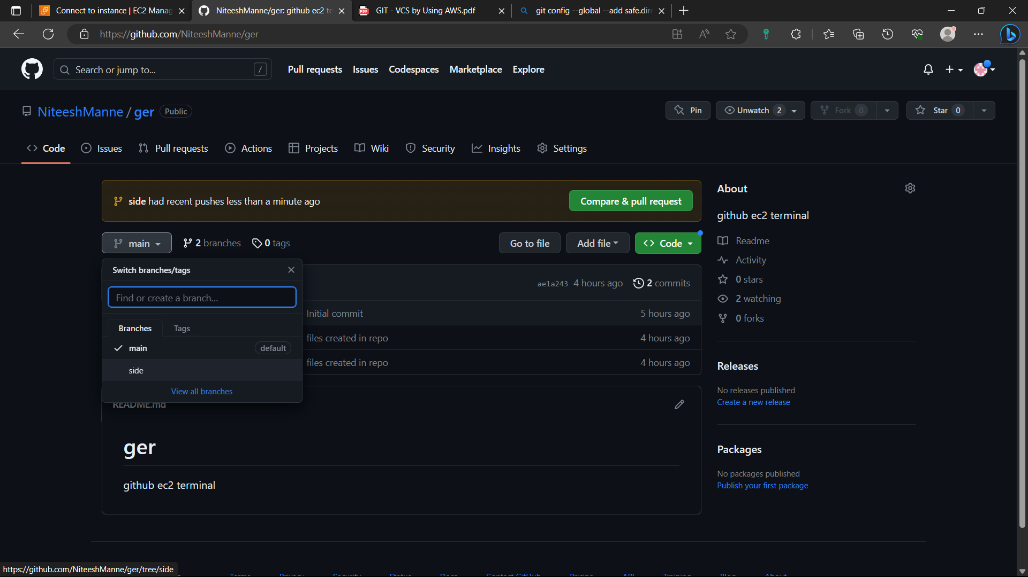

67.you will see the file i.e., pushed from local repository to remote repository.

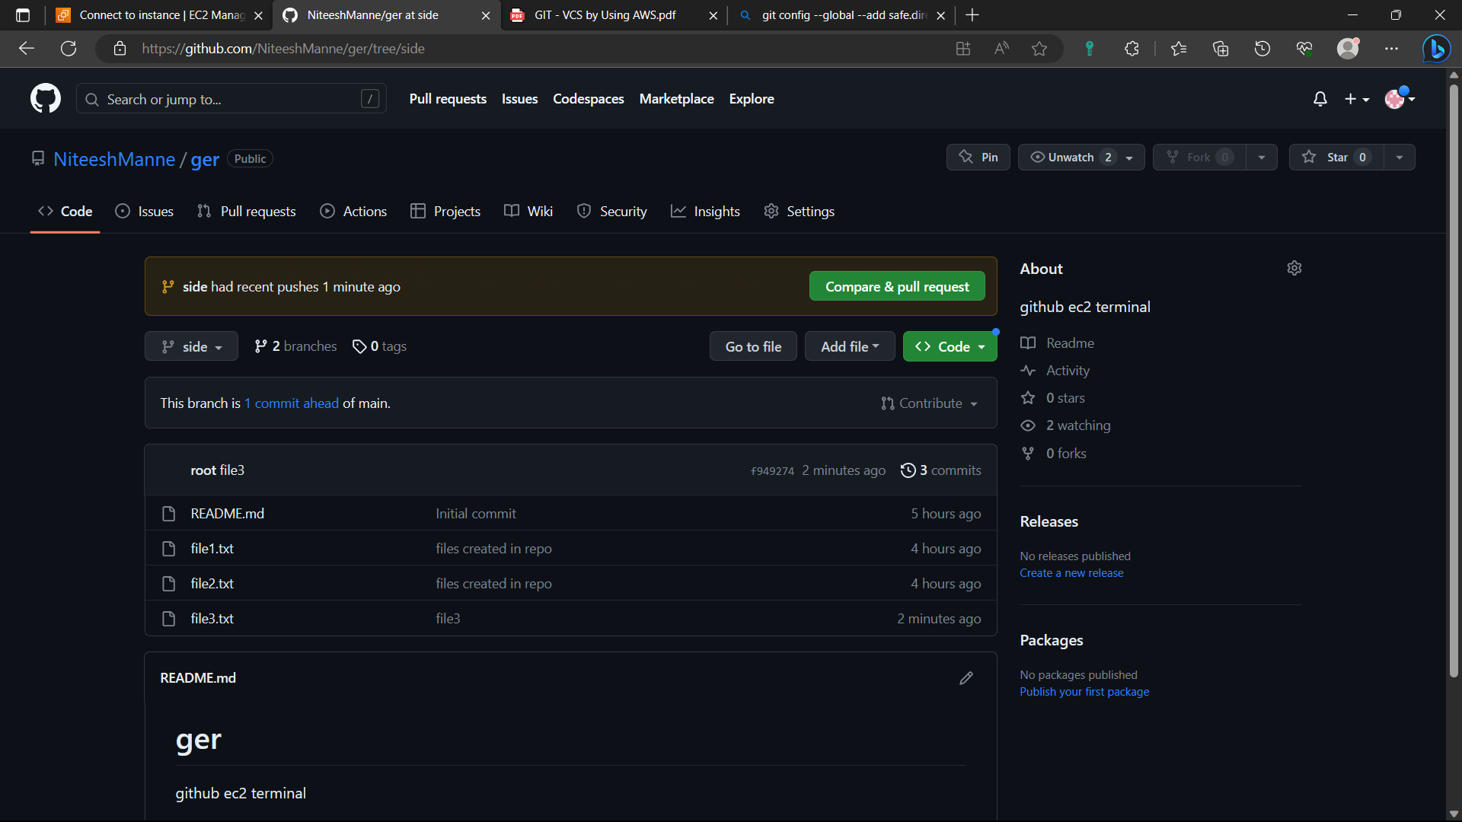

68. Go to github repository and navigate to pull requests tab.

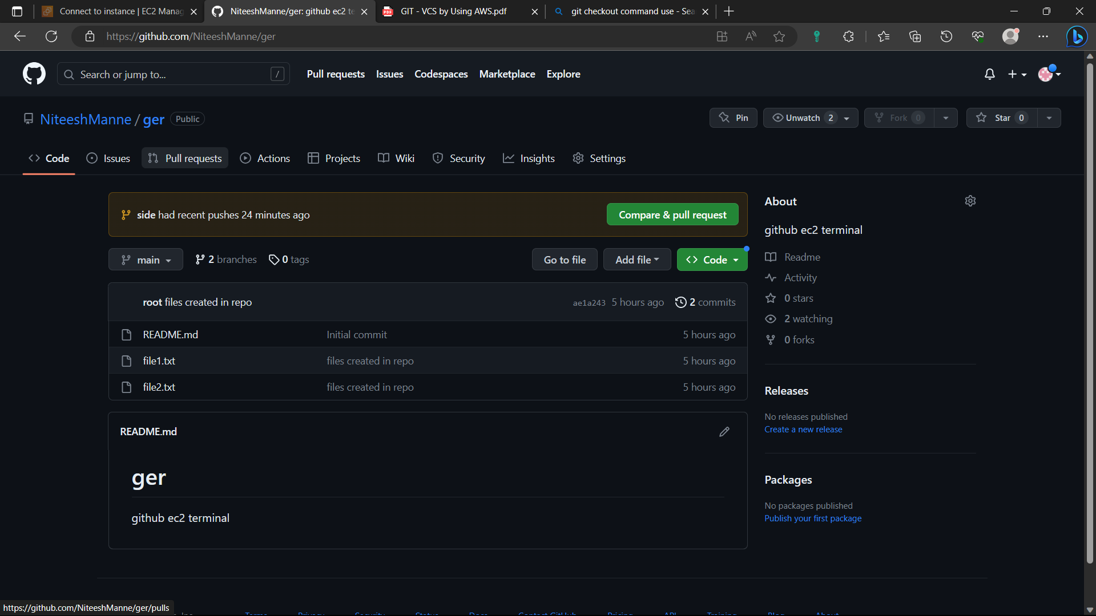

69. Click new pull request.

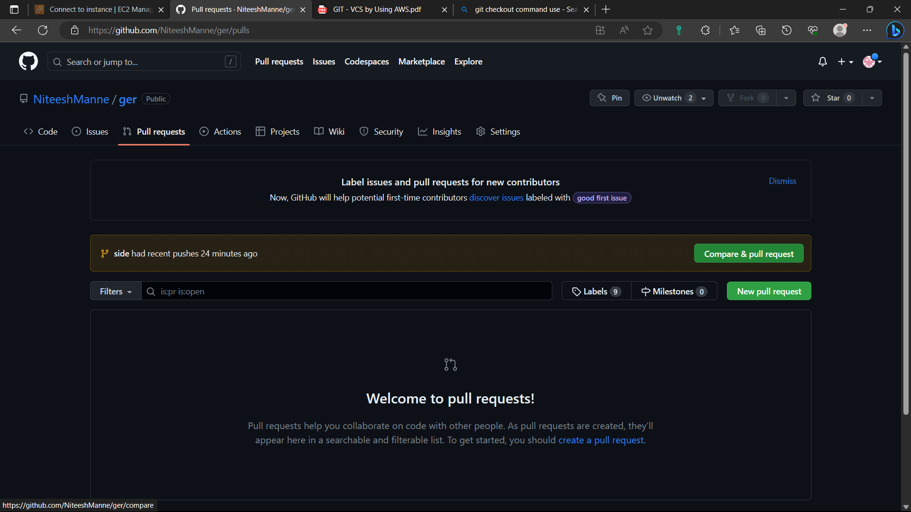

70.Now set the branches main<----side(where you want to merge/merging branch name).click on create pull request.

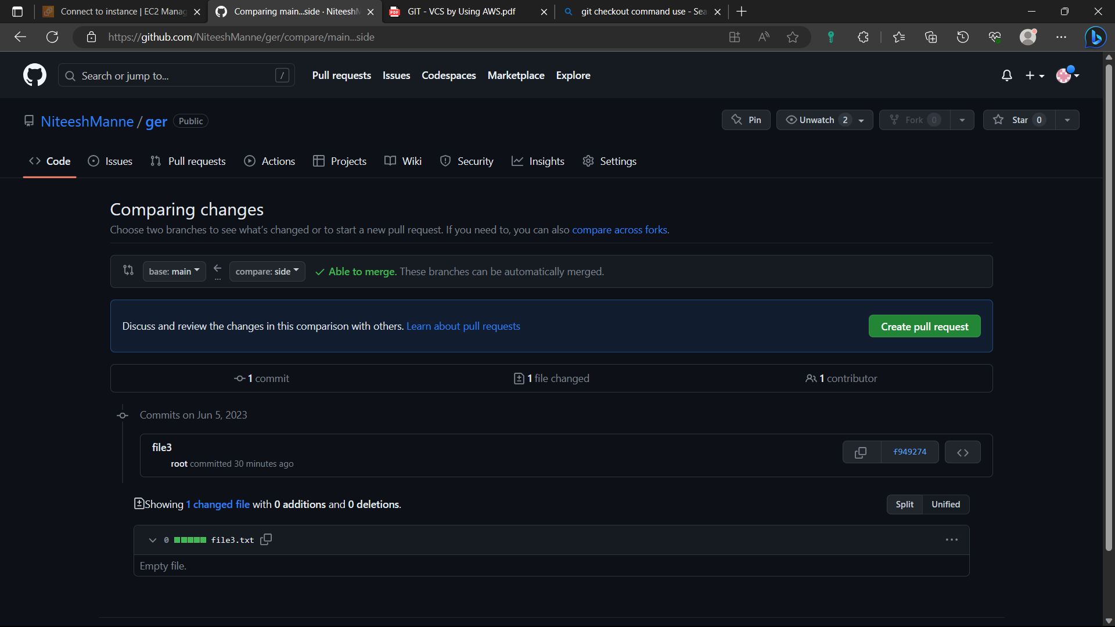

71.It will ask for a comment leave it blank and click on create pull request.

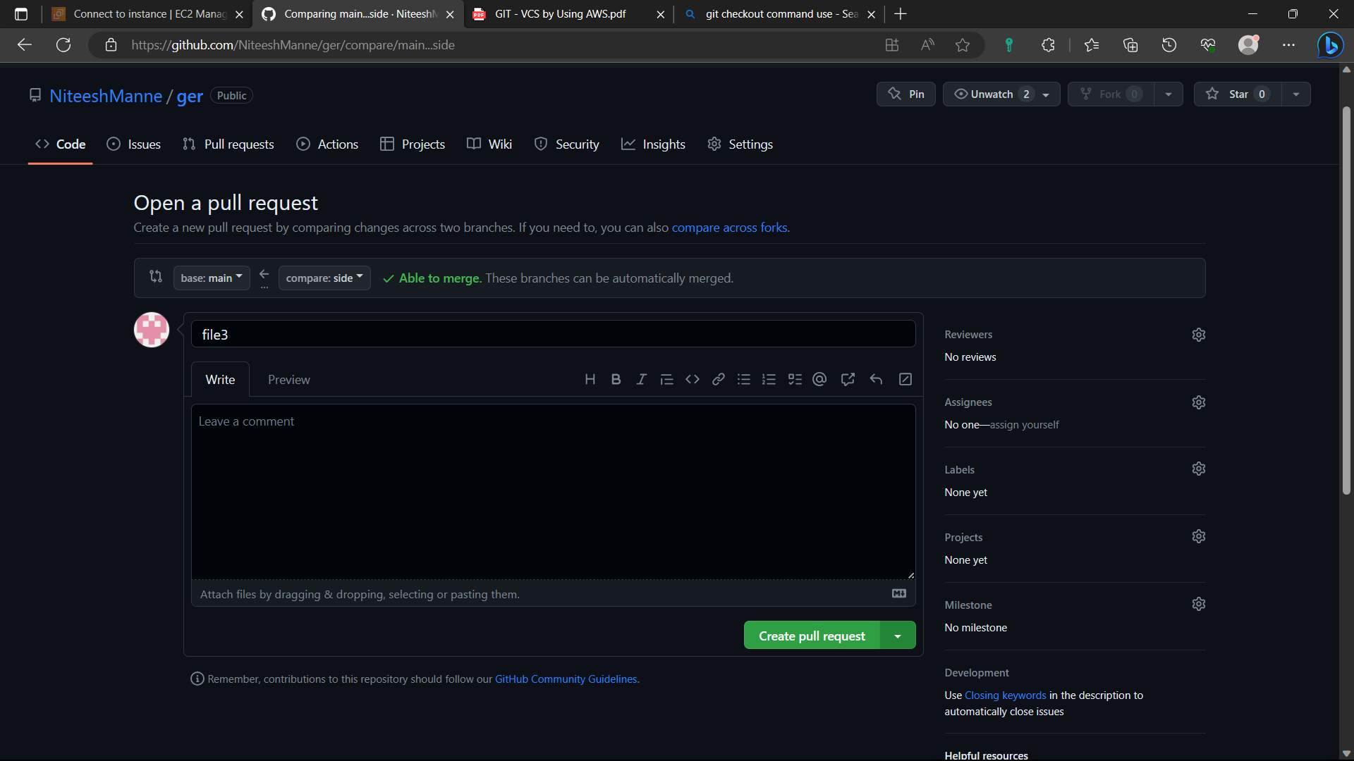

72.Review the changes and click on merge pull request.

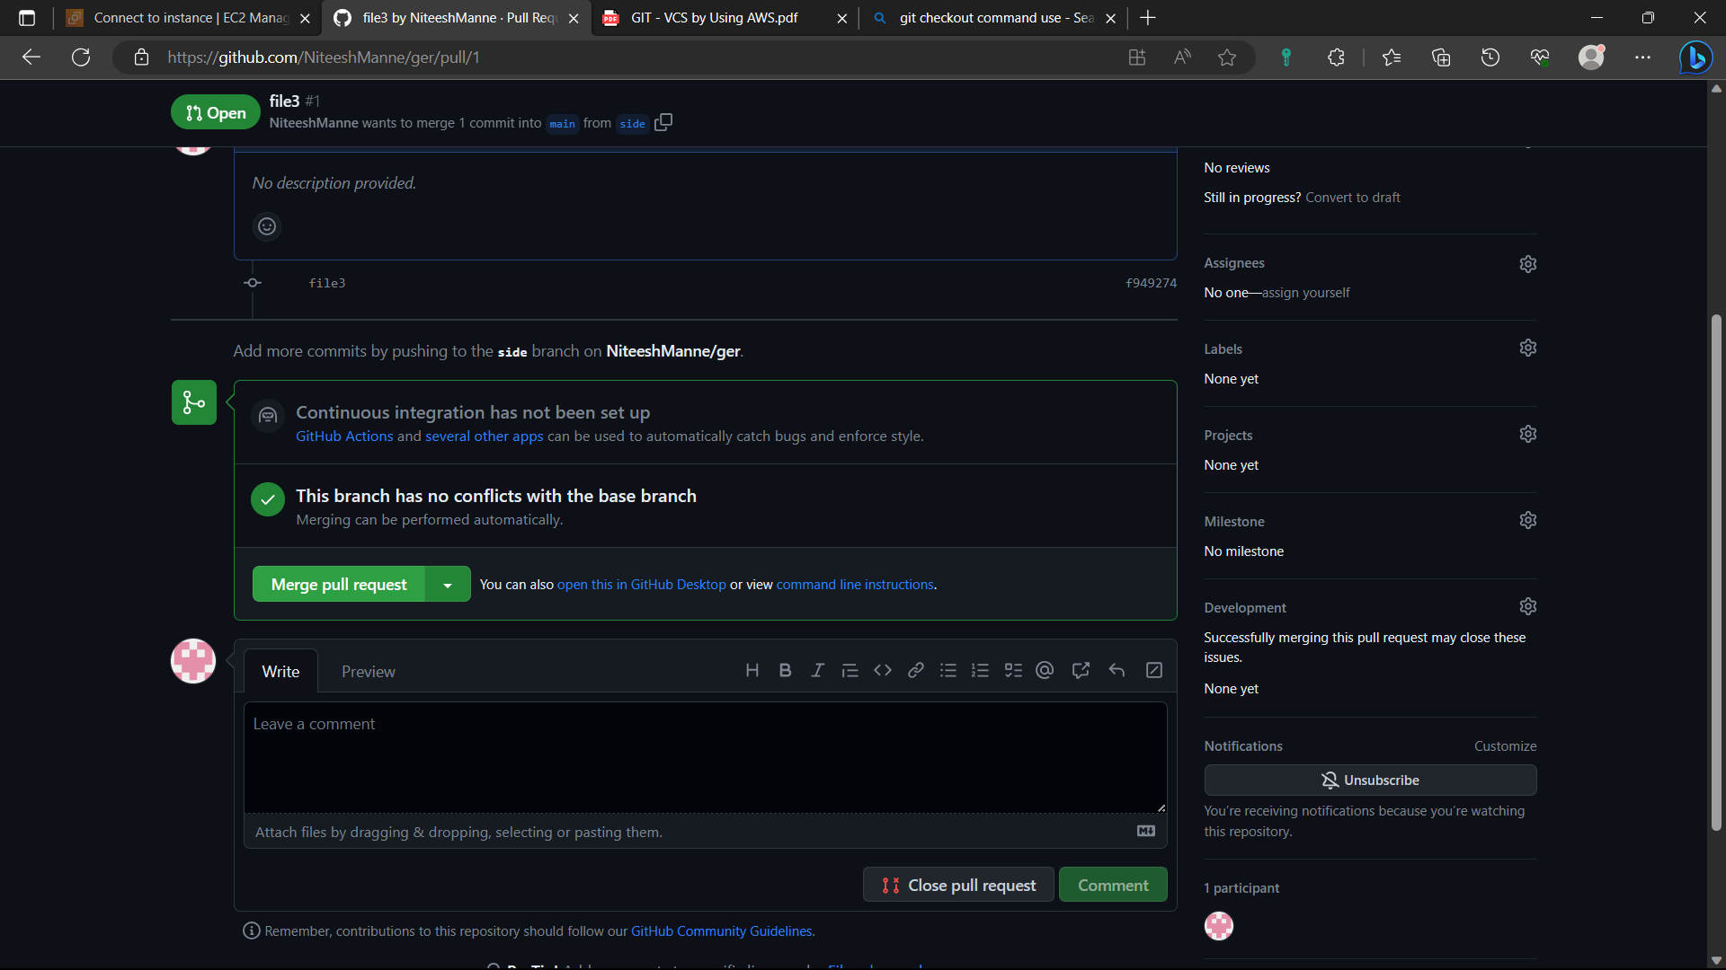

73.The merging is completed.

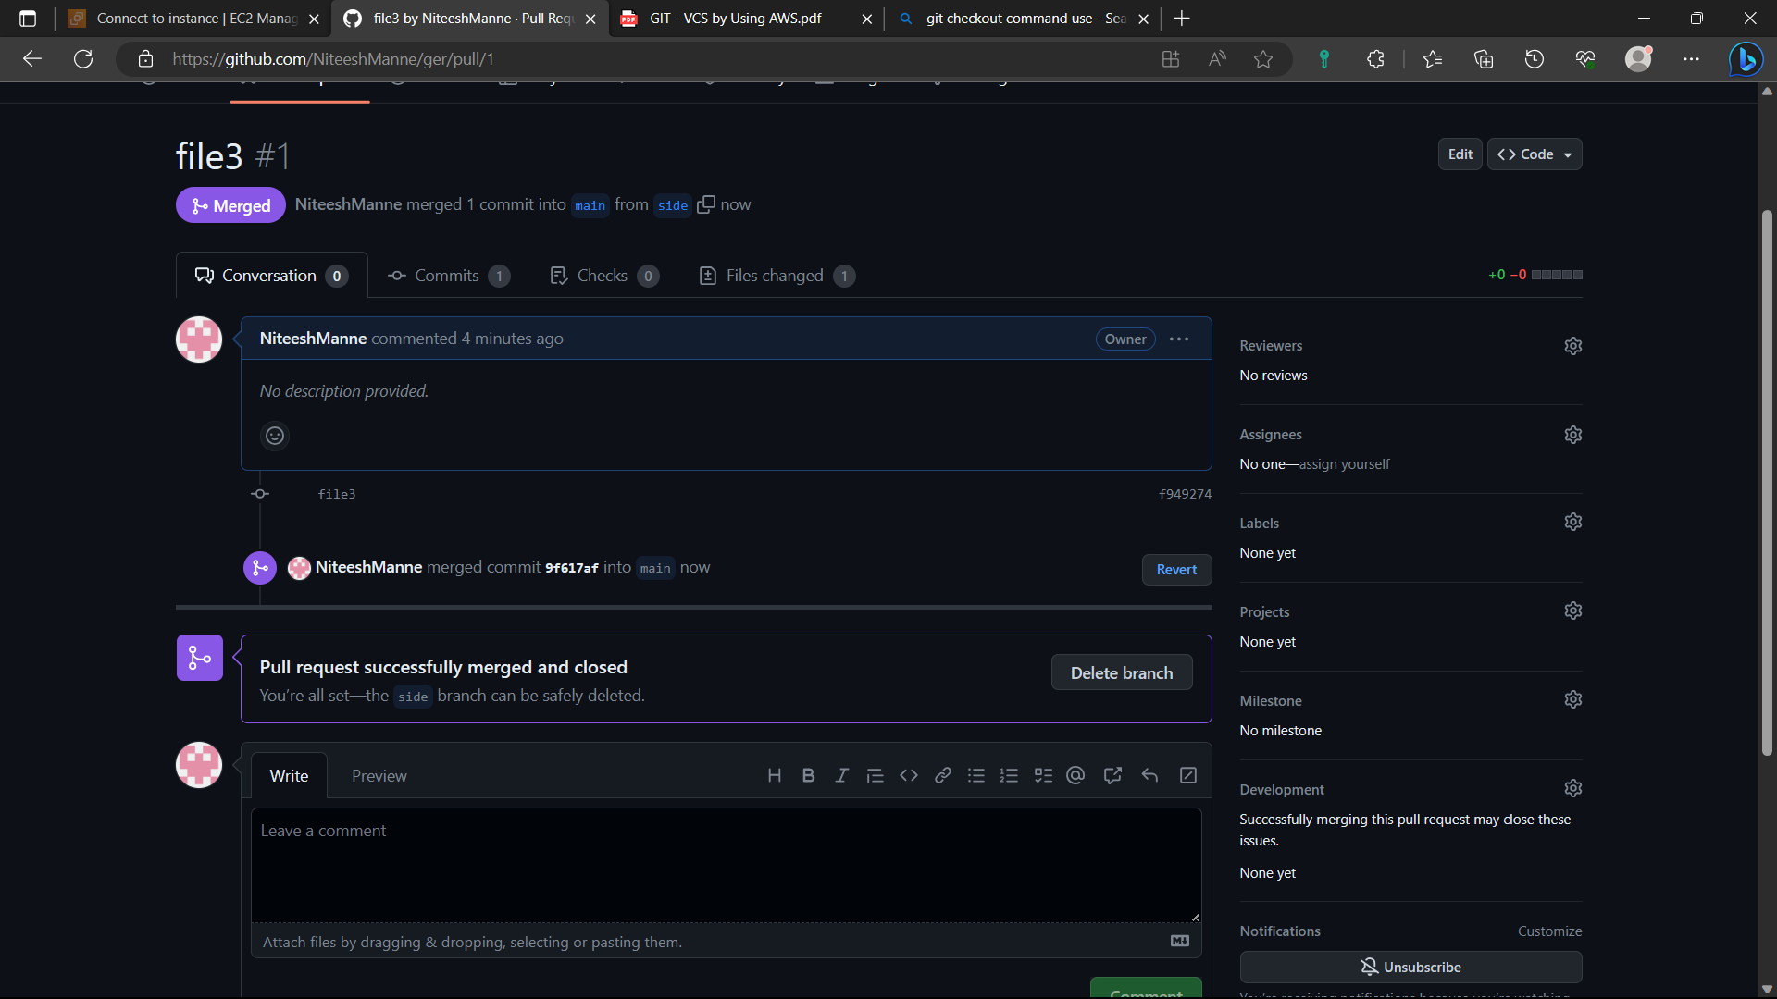

74.We can see that the file i.e., file3.txt which is present in side branch online has now appeared in main branch because of merging.

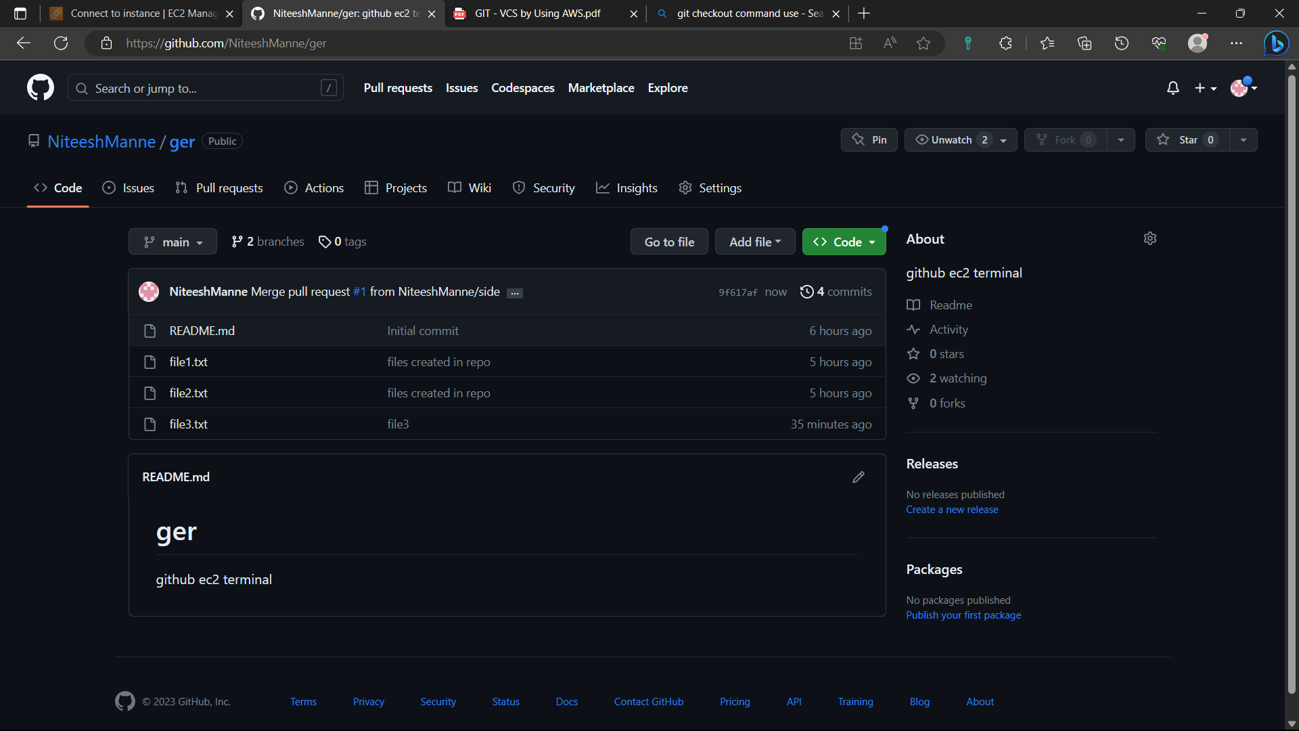

75.Go to the local repo where the side branch is created.

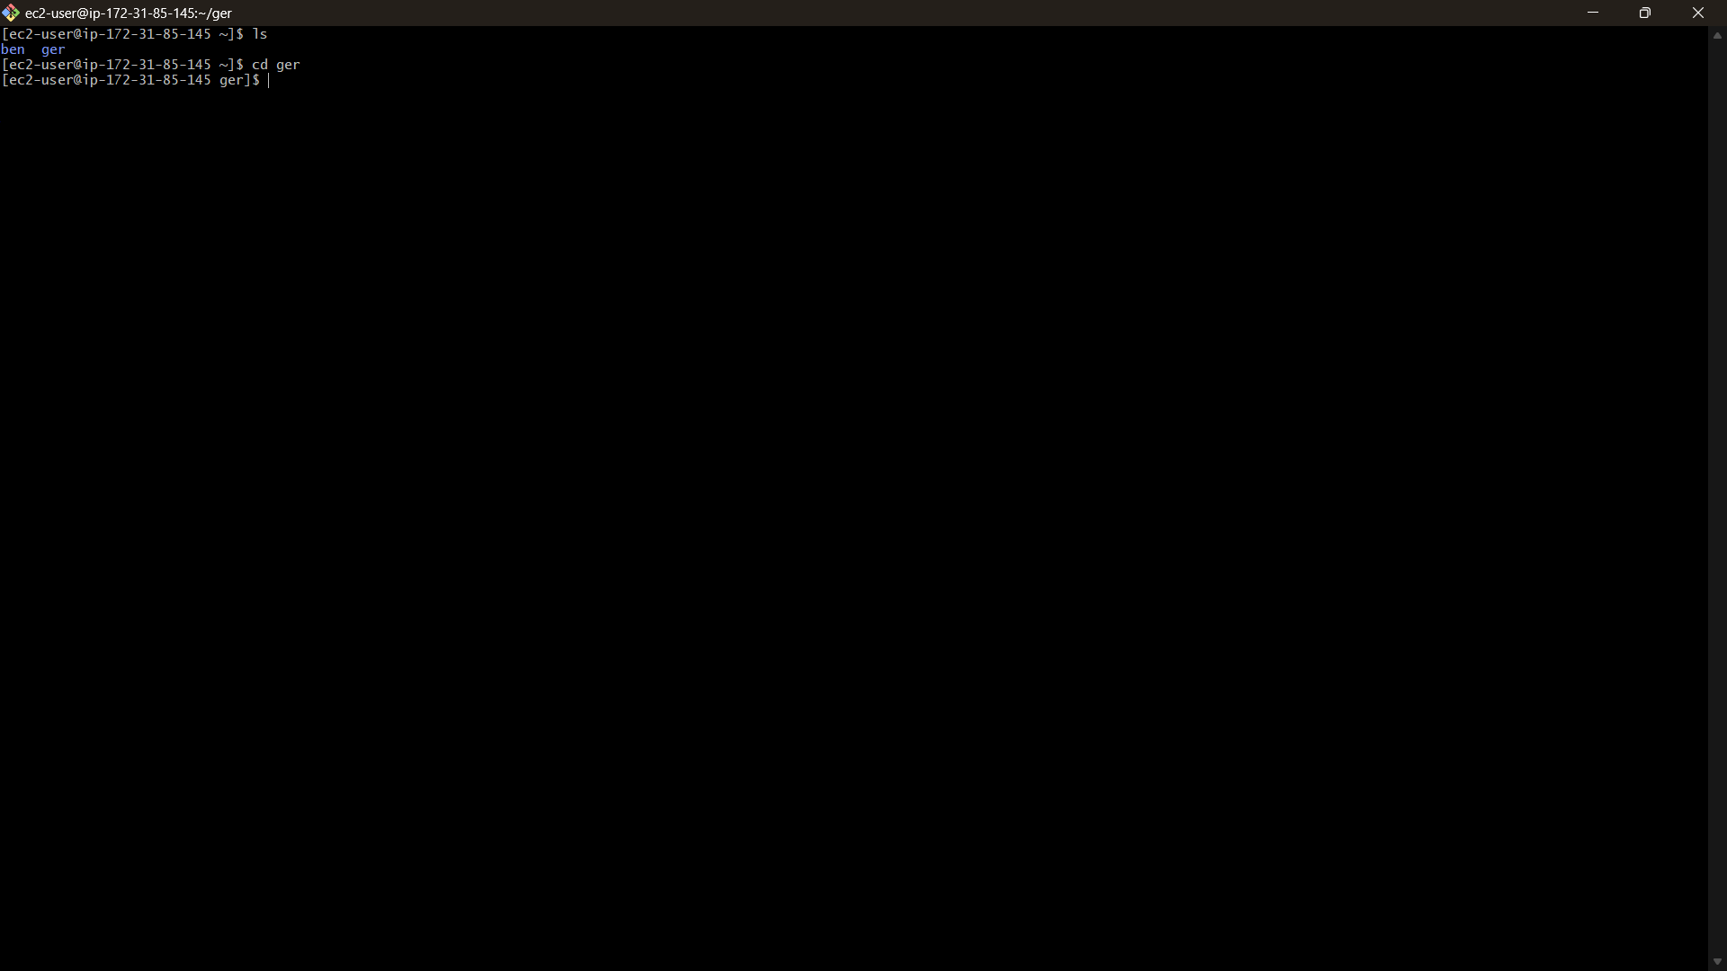

76.Now we are in side branch, switch to main branch using “git checkout <branchname>”. Also check it using “git status”.

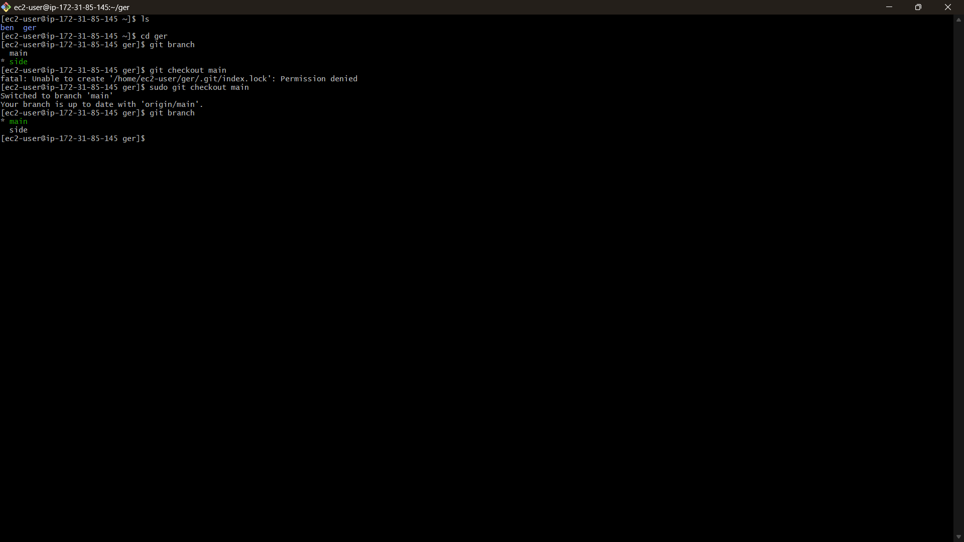

77.Now type the command : “git pull”. It will show all the latest changes happened to the main branch at github after merging.

 